Fields of Advanced Difficulty

Practical

1. Synthetic techniques: filtration, recrystallisation, drying of precipitates, thin layer chromatography.

2. Use of a simple digital conductivity meter.

Safety
The participants of the Olympiad must be prepared to work in a chemical laboratory and be aware of the necessary rules and safety procedures. The organizers will enforce the safety rules given in Appendix A of the IChO Regulations during the Olympiad.
The Preparatory Problems are designed to be carried out only in properly equipped chemical laboratories under competent supervision. We did not include specific and detailed safety and disposal instructions as regulations are different in each country. Mentors must carefully adapt the problems accordingly.
The safety (S) and risk (R) phrases associated with the materials used are indicated in the problems. See the Appendix B of the Regulations for the meaning of the phrases. The Regulations are available on our website.

Materials marked with a dagger, †, will not be used at the Olympiad.
Practical problems
- The preparation and analysis of polyiodide salts
The propensity for iodine to catenate is well illustrated by the numerous polyiodides, which crystallise from solutions containing iodide ions and iodine. The stoichiometry of the crystals and the detailed geometry of the polyhalide depend very sensitively on the relative concentrations of the components and the nature of the cation.
In this experiment, you will generate and crystallise a quaternary ammonium polyiodide salt of the form Me₄N⁺I_{n}– (n = 3, 5 or 7) and then titrate the amount of iodine in the anion using sodium thiosulphate. From the results of this analysis, you can determine which anion is present in your salt.

Experimental
Two salts, A and B, of different composition may be prepared by using different quantities of starting materials, as shown below. You can carry out the experiment for either one or both.
 | Salt A | Salt B
mass of NMe₄I / g | 1.00 | 0.50
mass of iodine / g | 1.26 | 1.26

Preparation
1. Add the iodine to a 100 cm³ beaker containing 25 cm³ ethanol and a magnetic bar. Heat and stir the solution until all the iodine has dissolved, then add the tetramethylammonium iodide. Continue to stir with moderate heating until no white solid remains. Do not allow the solution to boil at any time.
2. Allow the solution to cool slowly to room temperature and finally in an ice bath over about 15 – 20 minutes.
3. Collect the product under suction (Hirsch funnel) and wash on the filter with cold ethanol (10 cm³) followed by ether (10 cm³) using a disposable pipette.
4. Allow the product to dry on the filter for several minutes, and then transfer the crystals onto a filter paper. Place into a desiccator and leave under vacuum to dry.

Analysis
5. Weigh approximately 0.5g of the product onto a weighing boat using a four decimal place balance. Record the weight accurately.
6. Using a distilled water wash-bottle, carefully transfer all the weighed product into a 250 cm³ bottle.
7. Add approximately 25 cm³ of dichloromethane, replace the stopper and shake to extract the iodine into the organic layer.
8. Fill a 50 cm³ burette with sodium thiosulfate (0.100M) using a small glass funnel.
9. Remove the funnel and titrate the iodine by running small quantities of the sodium thiosulfate from the burette and then replacing the stopper and shaking the bottle.
10. The end-point is very sharp and is given by the removal of all iodine colour from the dichloromethane.

Questions
From the results of the titrations, calculate the formulae of the salts A and B. What are the shapes of the anions?
Substance |  | R phrases | S phrases
tetramethylammonium iodide | solid | 36/37/38 | 26-36
iodine | solid | 20/21-50 | 23-25-61
sodium thiosulfate | 0.1 M solution | 36/37/38 | 24/25
dichloromethane | liquid | 40 | 23-24/25-36/37
- The Williamson Synthesis of Ethers
Symmetrical aliphatic ethers may be prepared from the simpler primary and secondary alcohols by heating with sulphuric acid, but dehydration to the alkene is an important competing reaction. The sulphuric acid process is unsuited to the preparation of ethers from tertiary alcohols and of unsymmetrical ethers.
The Williamson synthesis, using an alkyl halide and a metal alkoxide, is of broader scope and can be used to obtain symmetrical or unsymmetrical ethers. For the latter type, either of two combinations of reactants is possible.
The proper choice depends mainly upon the structure of the alkyl halides involved. Competition arises between the substitution reaction (SN2) to an ether ( 1° > 2° >> 3° halides ) and the elimination of HX to form an alkene ( 3° >> 2° > 1° halides ). Therefore 3° halides are not suitable for the reaction, but ethers having a 3° alkyl group can be prepared from a 3° alkoxide and a 1° halide.
The Williamson synthesis is an excellent method for the preparation of alkylaryl ethers – 1° and 2° alkyl halides react readily with sodium or potassium phenoxides.
In this experiment benzyl chloride is reacted with 4-chlorophenol under basic conditions to produce an ether.
The use of a fume cupboard protective clothing including gloves is essential for this experiment.

Experimental
Add absolute ethanol (50 cm³) to potassium hydroxide pellets (0.87g) in a 100 cm³ round bottomed flask with a ground-glass joint.
Add 4-Chlorophenol (2g) followed by benzyl chloride (1.8 cm³) and lithium iodide (approx. 20 mg - the end of a micro-spatula).
Add a boiling stick, fit the flask with a condenser and heat under gentle reflux for 1 hour (an isomantle is recommended but keep careful control of the heating to maintain gentle reflux otherwise vigorous bumping can occur).
Allow the reaction mixture to cool and pour onto ice/water (150 cm³) with swirling. Isolate the crude product by suction filtration and wash with ice-cold water (3 x 10 cm³). Press dry on the filter.
The crude product should be recrystallised from aqueous ethanol. This entails dissolving your compound in the minimum volume of boiling ethanol and then adding water dropwise until the first crystals appear. Then set the hot solution aside to cool in the usual manner.
Record the yield of your product and run a thin layer chromatogram on a silica plate using ether/petroleum ether 2:8 as the eluent. Record the R_{f} value. Measure and record the m.p.

Questions
1. What is the role of the lithium iodide added to the reaction mixture?
2. Substantial increases in the rate of reaction are often observed if SN2 reactions are carried out in solvents such as dimethylformamide (DMF) or dimethylsulphoxide (DMSO). Suggest why this is so.
Substance |  | R phrases | S phrases
benzyl chloride † | liquid | 45-22-23-37/38-48/22-41 | 53-45
4-chlorophenol | solid | 20/21/22-51/53 | 28-61
potassium hydroxide | solid | 22-34-35 | 26-36/37/39-45
lithium iodide | solid | 36/37/38-61 | 22-26-45-36/37/39-53
diethyl ether | liquid | 12-19-66-67 | 9-16-29-33
petroleum ether † | liquid | 45-22 | 53-45
† This compound will not be used at the Olympiad
- Selective Reduction of a Highly Unsaturated Imine
Sodium borohydride is a selective reducing agent. In this experiment you will condense 3-nitroaniline with cinnamaldehyde to produce the highly unsaturated intermediate A (an imine). This is then selectively reduced with sodium borohydride to produce B. The structure of B can be deduced from the ¹H NMR spectrum.
The experiment illustrates the classic method of imine formation (azeotropic removal of water).

Experimental
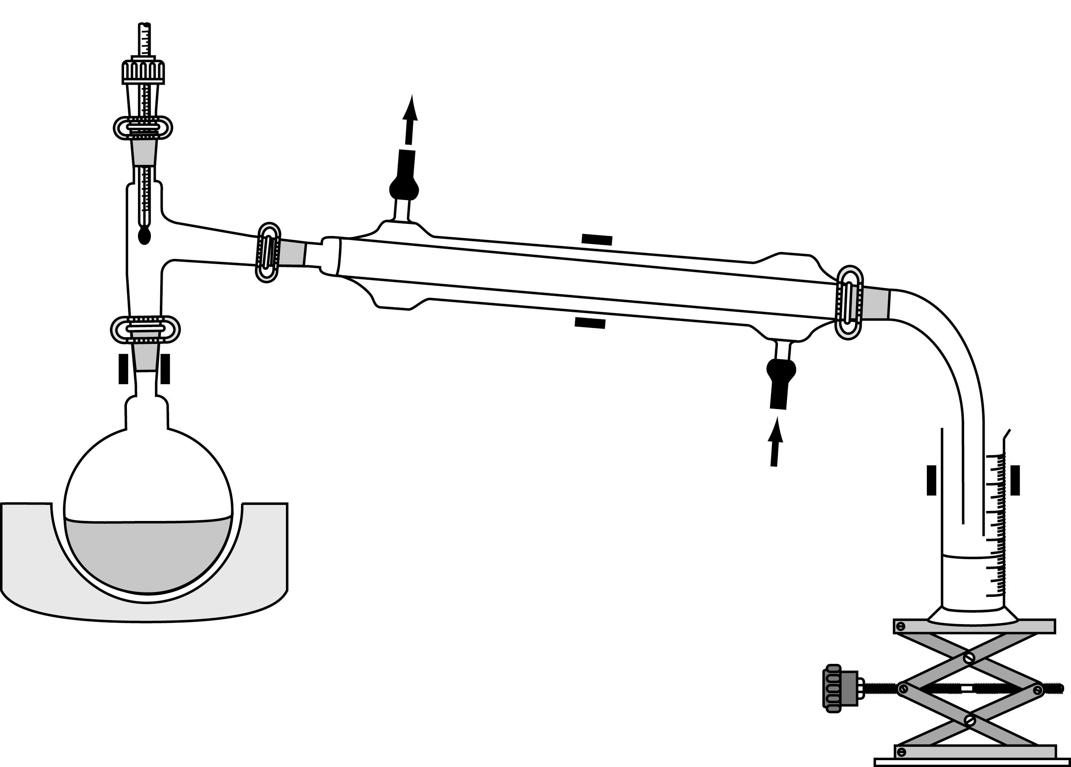
Place 3-Nitroaniline (2.76 g) and absolute ethanol (20 cm³) in a 100 cm³ round bottomed flask, together with a few anti-bumping granules. Set up the flask for distillation as shown above using an isomantle or steam bath as the heat source. Use a graduated measuring cylinder to collect the distillate.
Add dropwise a solution of cinnamaldehyde (2.9 g) in absolute ethanol (5 cm³) through the thermometer inlet. Turn on the heat source and distil off approx. 22 cm³ of solvent over a period of about 30 minutes. During the distillation dissolve with stirring sodium borohydride (0.76 g) in 95% ethanol (20 cm³).
After the 22 cm³ of solvent has distilled off, disconnect the apparatus. Set aside a small sample of the residue A which remains in the flask for thin layer chromatography. Then add 95 % ethanol (20 cm³) to the flask to dissolve the remaining residue. To this solution of A add VERY CAREFULLY the sodium borohydride solution. This must be added slowly and with constant swirling of the reaction flask (vigorous effervescence occurs). After the addition, heat the mixture under reflux for 15 minutes, then cool the flask and pour the contents into water (50 cm³). The product B, should crystallise out slowly on standing in an ice bath. Recrystallise your product from 95% ethanol.
Record the yield of your product. Run a thin layer chromatogram of your product B and the sample of A on a silica plate using hexane/ethyl acetate 1:1 as the eluent. Record the R_{f} value of each. Measure and record the m.p. of B. Predict the structure of B using the ¹H NMR spectrum given below.
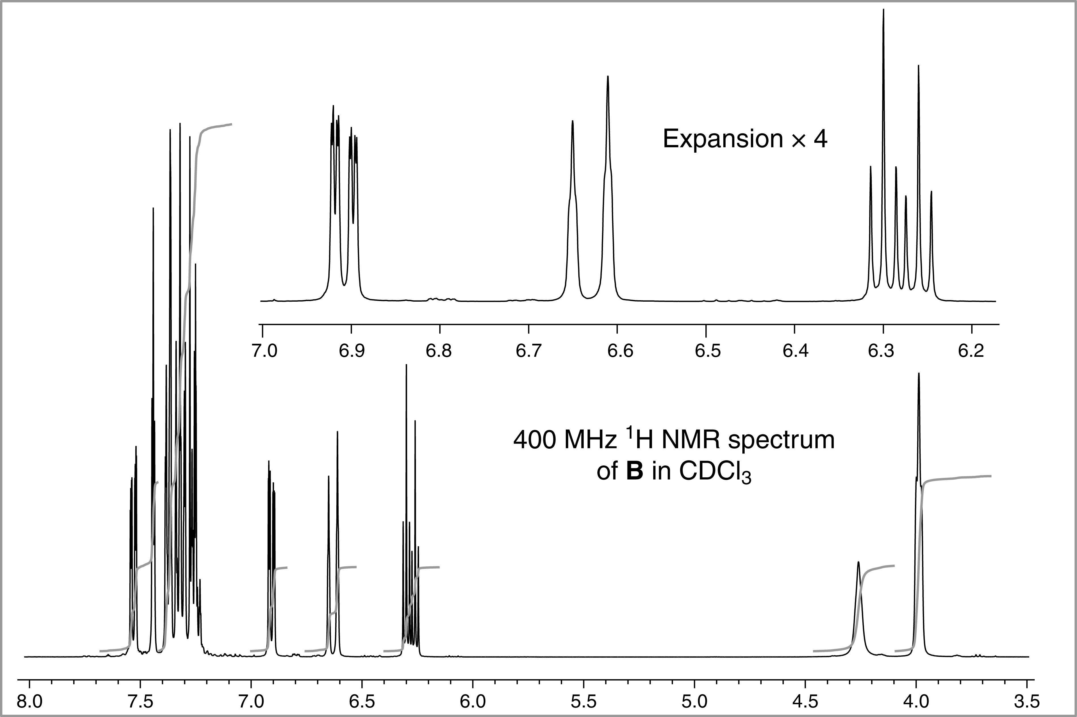

Questions
In the preparation of A why is absolute ethanol and not 95% used? Why is the solvent removed during the reaction?
Substance |  | R phrases | S phrases
3-nitroaniline | solid | 33-23/24/25-52/53 | 28-45-36/37-61
cinnamaldehyde | liquid | 41 | 26-39
sodium borohydride | solid | 25-34-43 | 26-27-28-45-36/37/39
hexane | liquid | 11-38-48/20-51/53-62-65-67 | 9-16-29-33-36/37-61-62
ethyl acetate | liquid | 11-36-66-67 | 16-26-33
- A Simple Aldol Codensation
The Claisen-Schmidt reaction involves the synthesis of an α,β-unsaturated ketone by the condensation of an aromatic aldehyde with a ketone. The aromatic aldehyde possesses no hydrogens α-to the carbonyl group, it cannot therefore undergo self condensation but reacts rapidly with the ketone present.
The initial aldol adduct cannot be isolated as it dehydrates readily under the reaction conditions to give an α,β-unsaturated ketone. This unsaturated ketone also possesses activated hydrogens α-to a carbonyl group and may condense with another molecule of the aldehyde.
In this experiment you will carry out the base catalysed aldol condensation of p-tolualdehyde with acetone. The product will be purified by recrystallisation and its structure determined using the spectra provided.

Experimental
Dissolve p-tolualdehyde (2.5 cm³) and acetone (1 cm³) in ethanol (25 cm³) contained in a stoppered flask. Add bench sodium hydroxide solution (5 cm³ of aqueous 10%) and water (20 cm³). Stopper the flask and shake it for 10 minutes, releasing the pressure from time to time. Allow the reaction mixture to stand for 5-10 minutes with occasional shaking and then cool in an ice bath. Collect the product by suction filtration, wash it well on the filter with cold water and recrystallise from ethanol.
Record the yield of your product. Run a thin layer chromatogram on a silica plate using ether/petroleum ether 2:8 as the eluent and record the R_{f} value of the product. Measure and record the m.p. of X.
Elemental analysis of X reveals it to have 88.99% carbon and 6.92% hydrogen. Use this information together with the NMR spectra to suggest a structure for X.
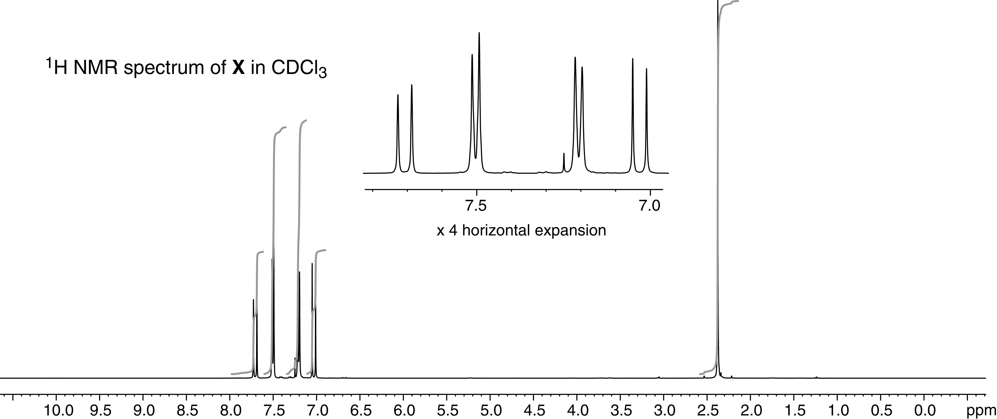
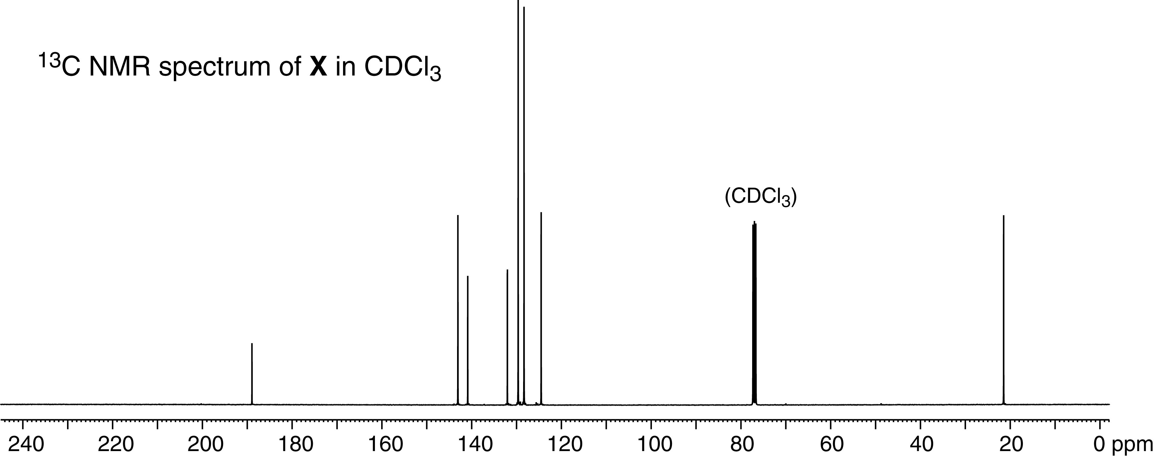

Substance |  | R phrases | S phrases
p-tolualdehyde | solid | 22-36/37/38 | 26-36
acetone | liquid | 11-36-66-67 | 9-16-26
sodium hydroxide | 10% aq. solution | 36/38 | 26
diethyl ether | liquid | 12-19-66-67 | 9-16-29-33
petroleum ether † | liquid | 45-22 | 53-45
† This compound will not be used at the Olympiad
- The Menshutkin Reaction
The nucleophilic substitution reaction between a tertiary amine and an alkyl halide is known as the Menshutkin reaction. This experiment investigates the rate law for the reaction between the amine known as DABCO (1,4-diazabicylo[2.2.2]octane) and benzyl bromide:
It is possible for the second nitrogen in the DABCO molecule to react with a second benzyl bromide. However, in this experiment the DABCO will always be in excess so further reaction is unlikely. The reaction could proceed by either the SN1 or the SN2 mechanism. In this experiment, you will confirm that the order with respect to benzyl bromide is 1 and determine the order with respect to DABCO. This should enable you to distinguish between the two possible mechanisms.
As the reaction proceeds neutral species, DABCO and benzyl bromide, are replaced by charged species, the quaternary ammonium ion and Br–. Therefore the electrical conductivity of the reaction mixture increases as the reaction proceeds and so the progress of the reaction can be followed by measuring the electrical conductivity as a function of time.
Benzyl bromide is a lacrymator. This experiment should be performed in a fume cupboard.

The Method in Principle
The rate law for the reaction can be written as
$\frac{d[{\text{Br}}^{−}]}{dt}=k[\text{RBr}][\text{DABCO}]^{α}$ [1]
where we have assumed that the order with respect to the benzyl bromide, RBr, is 1 and the order with respect to DABCO is α.
In the experiment, the concentration of DABCO is in excess and so does not change significantly during the course of the reaction. The term $k[\text{DABCO}]^{α}$ on the right-hand side of Eqn. [1] is thus effectively a constant and so the rate law can be written
$\frac{d[{\text{Br}}^{−}]}{dt}=k_{\text{app}}[\text{RBr}]$ where $k_{\text{app}}=k[\text{DABCO}]^{α}$ [2]
kapp is the apparent first order rate constant under these conditions; it is not really a rate "constant", as it depends on the concentration of DABCO.
To find the order with respect to DABCO we measure kapp for reaction mixtures with different excess concentrations of DABCO. From Eqn. [2], and taking logs, we find
$\text{ln}k_{\text{app}}=\text{ln}k+α\text{ln}[\text{DABCO}]$ [3]
So a plot of ln kapp against ln [DABCO] should give a straight line of slope α.
kapp may be found by measuring the conductance at time t, G(t), and at time infinity, G∞. In the supplementary material it is shown that a graph of ln[G∞ –G(t)] against t should be a straight line with slope kapp.
In practice it is rather inconvenient to measure conductance at time infinity but this can be avoided by analysing the data using the Guggenheim method. In this method each reading of the conductance at time t, is paired up with another at time t + Δ, G(t+Δ), where Δ is a fixed time interval that needs to be at least a half-life. As shown in the supplementary material, a plot of ln[G(t+Δ)–G(t)] against time should be a straight line of slope –kapp. For example, suppose we take measurements at fixed regular intervals, say each 30 s and choose an appropriate value of Δ, say 3 minutes (180 s). The plot made is of the points {x,y} = {0, ln[G(180)-G(0)]},
{30, ln[G(210)-G(30)]}, {60, ln[G(240)-G(60)]}, ...

The Apparatus
Cheap conductivity meters are commercially available, for example the Primo5 conductivity stick meter from Hanna instruments works well with this practical. These simply dip into the solution and the conductance of the solution can be read off the digital display.
www.hannainst.co.uk/product/PRIMO5-Conductivity-stick-meter/PRIMO5/

Procedure
You are provided with the following solutions, all in ethanol: 0.15, 0.20 and 0.25 mol dm–3 DABCO, and approx. 0.6 mol dm–3 benzyl bromide (this must be freshly made up). You should measure kapp for each of these solutions by measuring the conductance as a function of time and then analysing the data using the Guggenheim method. From the three values of kapp, the order with respect to DABCO can be found by plotting ln kapp against ln [DABCO], as shown by Eqn. [3].
Ideally we ought to keep the reagents and the reaction mixture in a thermostat. However, as the heat evolved is rather small, the temperature will remain sufficiently constant for our purposes.

Kinetic Runs
1. Rinse the conductivity dipping electrode with ethanol from a wash bottle, catching the waste in a beaker. Allow the excess ethanol to drain off and gently dry the electrode with tissue.
2. Transfer 10 cm3 of the DABCO solution to a clean dry boiling tube.
3. Add 100 μl of the benzyl bromide solution.
4. Insert and withdraw the dipping electrode of the conductance meter a few times in order to mix the solution and then, with the electrode in place, start the stop-watch.
5. Record the conductance at 30 second intervals (it is essential to make the measurements at regular intervals), starting with the first reading at 30 seconds and continuing until there is no further significant change in the conductance, or for 10 minutes, whichever is the shorter time.
6. From time to time, gently lift the electrode in and out so as to stir the solution.
7. Once the measurements have been made, remove the electrode, discard the solution and clean the electrode as in step 1.
8. Make the measurements for the 0.15 mol dm–3 solution of DABCO, and then for the 0.20 and 0.25 mol dm–3 solutions.

Data Analysis
For each run determine kapp using the Guggenheim method – three minutes is about right for the fixed interval Δ. Then plot ln kapp against ln [DABCO] and hence determine the order with respect to DABCO.
Substance |  | R phrases | S phrases
DABCO | 0.15, 0.20 and 0.25 M solutions in ethanol | 11-22-36/37/38 | 26-37
benzyl bromide | 0.6 M solution in ethanol | 36/37/38 | 26-39
Supplementary information
The key to this experiment is how to use the measured conductance of the reaction mixture to determine the first order rate constant, kapp. The first stage is simply to integrate the rate law; to do this we note that for each benzyl bromide molecule that reacts one bromide ion is generated so that at any time [Br–] = [RBr]init – [RBr], where [RBr]init is the initial concentration of benzyl bromide. Thus the rate equation can be written in terms of [Br–] by putting [RBr] = [RBr]init – [Br–]; integration is then straightforward:
$$\begin{aligned}\frac{d[{\text{Br}}^{−}]}{dt}=k_{\text{app}}\left([\text{RBr}]_{\text{init}}−[{\text{Br}}^{−}]\right) \\ \int{\frac{d[{\text{Br}}^{−}]}{\left([\text{RBr}]_{\text{init}}−[{\text{Br}}^{−}]\right)}}=\int{k_{\text{app}}dt}\end{aligned}$$
i.e. $−\text{ln}\left([\text{RBr}]_{\text{init}}−[{\text{Br}}^{−}]\right)=k_{\text{app}}t+\text{ const}\text{.}$
The constant can be found by saying that at time zero, [Br–] = 0, hence
$$−\text{ln}\left([\text{RBr}]_{\text{init}}\right)=\text{ const}\text{.}$$
hence $−\text{ln}\left([\text{RBr}]_{\text{init}}−[{\text{Br}}^{−}]\right)=k_{\text{app}}t−\text{ln}\left([\text{RBr}]_{\text{init}}\right)$
which can be written
$[{\text{Br}}^{−}]=[\text{RBr}]_{\text{init}}\left(1−\text{exp}[−k_{\text{app}}t]\right)$ [4]
When the reaction has gone to completion, at time infinity, the concentration of bromide is equal to the initial concentration of RBr so Eqn. [4] can be written
$[{\text{Br}}^{−}]=[{\text{Br}}^{−}]_{∞}\left(1−\text{exp}[−k_{\text{app}}t]\right)$ [5]
where $[{\text{Br}}^{−}]_{∞}$ is the concentration of Br– at time infinity. Equation [5] says that the concentration of Br– approaches a limiting value of $[{\text{Br}}^{−}]_{∞}$ with an exponential law. A similar relationship can be written for the other product, the quaternary ammonium ion, whose concentration will be written $[R_{4}{\text{Br}}^{+}]$.
$[R_{4}{\text{Br}}^{+}]=[R_{4}{\text{Br}}^{+}]_{∞}\left(1−\text{exp}[−k_{\text{app}}t]\right)$ [6]
We will assume that the conductance of the reaction mixture, G, is proportional to the concentration of the charged species present:
$$G=λ_{{\text{Br}}^{−}}[{\text{Br}}^{−}]+λ_{R_{4}N^{+}}[R_{4}N^{+}]$$
where λ are simply the constants of proportionality.

Using Eqns. [5] and [6] to substitute for the concentration of Br– and R4N+ we find
$$\begin{aligned}G=λ_{{\text{Br}}^{−}}\left\{[\text{Br}−]_{∞}\left(1−\text{exp}[−k_{\text{app}}t]\right)\right\}+λ_{R_{4}N^{+}}\left\{[R_{4}{\text{Br}}^{+}]_{∞}\left(1−\text{exp}[−k_{\text{app}}t]\right)\right\} \\ =\left(λ_{{\text{Br}}^{−}}[\text{Br}−]_{∞}+λ_{R_{4}N^{+}}[R_{4}{\text{Br}}^{+}]_{∞}\right)\left(1−\text{exp}[−k_{\text{app}}t]\right) \\ =G_{∞}\left(1−\text{exp}[−k_{\text{app}}t]\right) [7]\end{aligned}$$
where we have recognised that $\left(λ_{{\text{Br}}^{−}}[\text{Br}−]_{∞}+λ_{R_{4}N^{+}}[R_{4}{\text{Br}}^{+}]_{∞}\right)$ is the conductance at time infinity, G∞.
Equation [7] can be rearranged to give a straight line plot:
$$1−\frac{G}{G_{∞}}=\text{exp}[−k_{\text{app}}t]$$
$\text{ln}\left(1−\frac{G}{G_{∞}}\right)=−k_{\text{app}}t$ or $\text{ln}\left(\frac{G_{∞}−G}{G_{∞}}\right)=−k_{\text{app}}t$
or $\text{ln}\left(G_{∞}−G\right)=−k_{\text{app}}t+\text{ln}G_{∞}$
Hence a plot of $\text{ln}\left(G_{∞}−G\right)$ against t should be a straight line with slope kapp.

The Guggenheim Method
From Eqn. [9] the conductance at time t, G(t), can be written
$$G(t)=G_{∞}\left(1−\text{exp}[−k_{\text{app}}t]\right)$$
At some time (t + Δ) later the conductance is G(t + Δ)
$$G(t+Δ)=G_{∞}\left(1−\text{exp}[−k_{\text{app}}(t+Δ)]\right)$$
The difference G(t + Δ) – G(t) is
$$G(t+Δ)−G(t)=G_{∞}\left(1−\text{exp}[−k_{\text{app}}(t+Δ)]−1+\text{exp}[−k_{\text{app}}t]\right)$$
$=G_{∞}\left(\text{exp}[−k_{\text{app}}t]−\text{exp}[−k_{\text{app}}(t+Δ)]\right)$
$=G_{∞}\text{exp}[−k_{\text{app}}t]\left(1−\text{exp}[−k_{\text{app}}Δ]\right)$
Taking logarithms of both sides gives, from the last line,
$$\text{ln}\left(G(t+Δ)−G(t)\right)=\text{ln}G_{∞}−k_{\text{app}}t+\text{ln}\left(1−\text{exp}[−k_{\text{app}}Δ]\right)$$
This implies that a plot of $\text{ln}\left(G(t+Δ)−G(t)\right)$ against time should be a straight line of slope –kapp; to make this plot there is no need to know the value of the conductance at infinite time, G∞, and this is the main advantage of the Guggenheim method.

