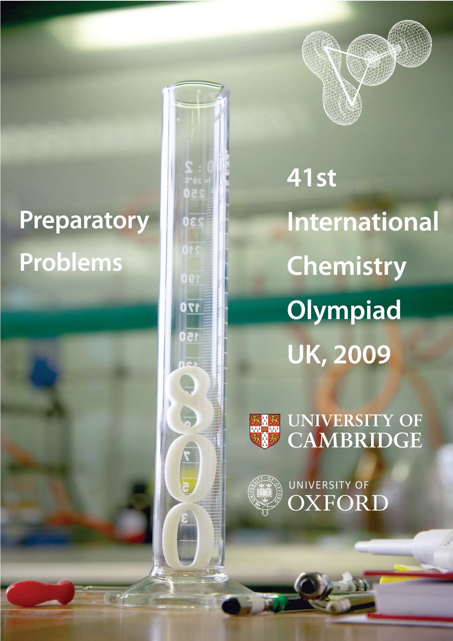
Problem Authors

Stephen Ashworth University of East Anglia
Jonathan Burton University of Oxford
Jon Dilworth University of Oxford
Nicholas Green University of Oxford
Philip Mountford University of Oxford
William Nolan University of Cambridge
Jeremy Rawson University of Cambridge
Kathryn Scott University of Oxford
Malcolm Seddon University of East Anglia
Simon Titmuss University of Oxford
Claire Vallance University of Oxford
Peter Wothers University of Cambridge
Fields of Advanced Difficulty

Theoretical

Kinetics: integrated first-order rate equation; analysis of moderately complex reactions mechanisms using the steady state approximation, the use of the Arrhenius equation, simple collision theory

Thermodynamics: electrochemical cells, the relationship between equilibrium constants, electromotive force and standard Gibbs energy, the variation of the equilibrium constant with temperature

Quantum mechanics: calculation of orbital and spin angular momentum, calculation of the magnetic moment using the spin-only formula

Spectroscopy: interpretation of relatively simple ¹³C and ¹H NMR spectra; chemical shifts, multiplicities, coupling constants and integrals

Mass spectrometry: molecular ions and basic fragmentation

Theoretical problems
- Dating moon rock
The age of rocks collected from the moon on the Apollo 16 mission has been determined from the ⁸⁷Rb / ⁸⁶Sr and ⁸⁷Sr / ⁸⁶Sr ratios of different minerals found in the sample.
Mineral | ⁸⁷Rb / ⁸⁶Sr | ⁸⁷Sr / ⁸⁶Sr
A (Plagioclase) | 0.004 | 0.699
B (Quintessence) | 0.180 | 0.709
- ⁸⁷Rb is a β– emitter, write down the equation of nuclear decay. The half-life for this decay is 4.8 × 10¹⁰ years.
- Calculate the age of the rock. You can assume that the initial ⁸⁷Sr / ⁸⁶Sr is the same in A and B and that ⁸⁷Sr and ⁸⁶Sr are stable.
- Snorkelling
The pressure of a gas may be thought of as the force the gas exerts per unit area on the walls of its container, or on an imaginary surface of unit area placed somewhere within the gas. The force arises from collisions between the particles in the gas and the surface. In an ideal gas, the collision frequency (number of collisions per second) with a surface of unit area is given by:
$$Z_{\text{surface}}=\frac{p}{\sqrt{2πmk_{B}T}}$$
Where p is the pressure and T the temperature of the gas, m is the mass of the gas particles, and k_{B} is the Boltzmann’s constant (k_{B} = 1.38×10^{–23} J K^{–1}).
At sea level, atmospheric pressure is generally around 101.3 kPa, and the average temperature on a typical British summer day is 15°C.
- Using the approximation that air consists of 79% nitrogen and 21% oxygen, calculate the weighted average mass of a molecule in the air.
- Human lungs have a surface area of approximately 75 m². An average human breath takes around 5 seconds. Estimate the number of collisions with the surface of the lungs during a single breath on a typical British summer day. You should assume that the pressure in the lungs remains constant at atmospheric pressure; this is a reasonable approximation, as the pressure in the lungs changes by less than 1% during each respiratory cycle.
The human lungs can operate against a pressure differential of up to one twentieth of atmospheric pressure. If a diver uses a snorkel for breathing, we can use this fact to determine how far below water the surface of the water she can swim.
The pressure experienced by the diver a distance d below the surface of the water is determined by the force per unit area exerted by the mass of water above her. The force exerted by gravity on a mass m is F = mg, where g = 9.8 m s^{–2} is the acceleration due to gravity.
- Write down an expression for the mass of a volume of water with cross sectional area A and depth d.
- Derive an expression for the force exerted on the diver by the volume of water in (c), and hence an expression for the difference in pressure she experiences at depth d relative to the pressure at the water’s surface.
- Calculate the maximum depth the diver can swim below the water surface, while still breathing successfully through a snorkel.

- Ideal and not-so-ideal gases
The force a gas exerts on the walls of its container arises from collisions between the particles in the gas and the surface. In a single collision, the magnitude of the impulsive of the force exerted on the surface is equal to the change in the momentum normal to the surface, mΔv. The force on the surface is then the impulse, multiplied by the rate at which the particles collide with the surface.
Since the motion of particles within a gas is random, the number of collisions occurring per unit time is a constant for a gas at constant temperature.
The temperature of a gas reflects the distribution of particle velocities within the gas. For a given gas, the particle speeds will be higher, on average, at higher temperatures.
- Given the above information, and assuming the gas is initially at room temperature and atmospheric pressure, consider how carrying out the following actions would be likely to affect the pressure. Would the pressure double, halve, increase slightly, decrease slightly, or remain unchanged?
  - Doubling the number of particles in the gas.
  - Doubling the volume of the container in which the gas is confined.
  - Doubling the mass of the particles in the gas (assume that the particle velocities remain constant).
  - Increasing the temperature by 10°C.
The ideal gas model assumes that there are no interactions between gas particles. Particles in a real gas do interact through a range of forces such as dipole–dipole forces, dipole–induced–dipole forces, and van der Waals interactions (induced–dipole–induced–dipole forces). A typical curve showing the potential energy of interaction between two particles is shown right: | 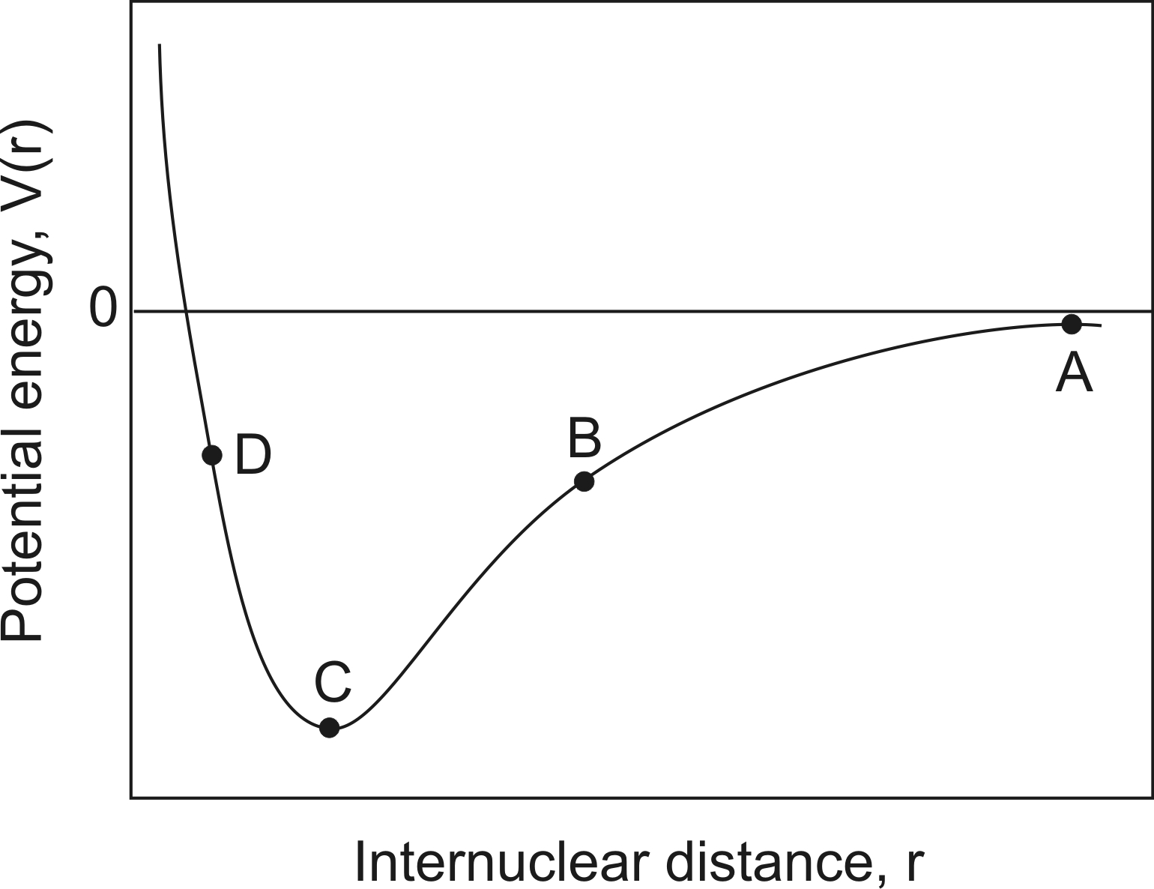
The force between two particles in a gas at a given separation r may be calculated from the gradient of the potential energy curve i.e. F = –dV / dr.
- What is the force at the four points marked A, B, C and D on the figure?
(attractive / repulsive / approximately zero)
The deviation from non-ideality in a gas is often quantified in terms of the compression ratio, Z.
$$Z=\frac{V_{m}}{V_{m}^{0}}$$
where $V_{m}$is the molar volume of the (real) gas, and $V_{m}^{0}$ is the molar volume of an ideal gas under the same conditions of temperature, pressure etc.
- Match the following values of Z with the dominant type of interaction in the gas.
[ Z = 1 ] [ Z < 1 ] [Z > 1 ]
Attractive forces dominate
Repulsive forces dominate
No intermolecular forces, ideal gas behaviour
d) The compression ratio is pressure dependent. Consider the average separation between particles in a gas at different pressures (ranging from extremely low pressure to extremely high pressure), and the regions of the intermolecular potential that these separations correspond to. Sketch the way in which you think the compression ratio will vary with pressure on the set of axes below. [Note: do not worry about the actual numerical values of Z; the general shape of the pressure dependence curve is all that is required.] | 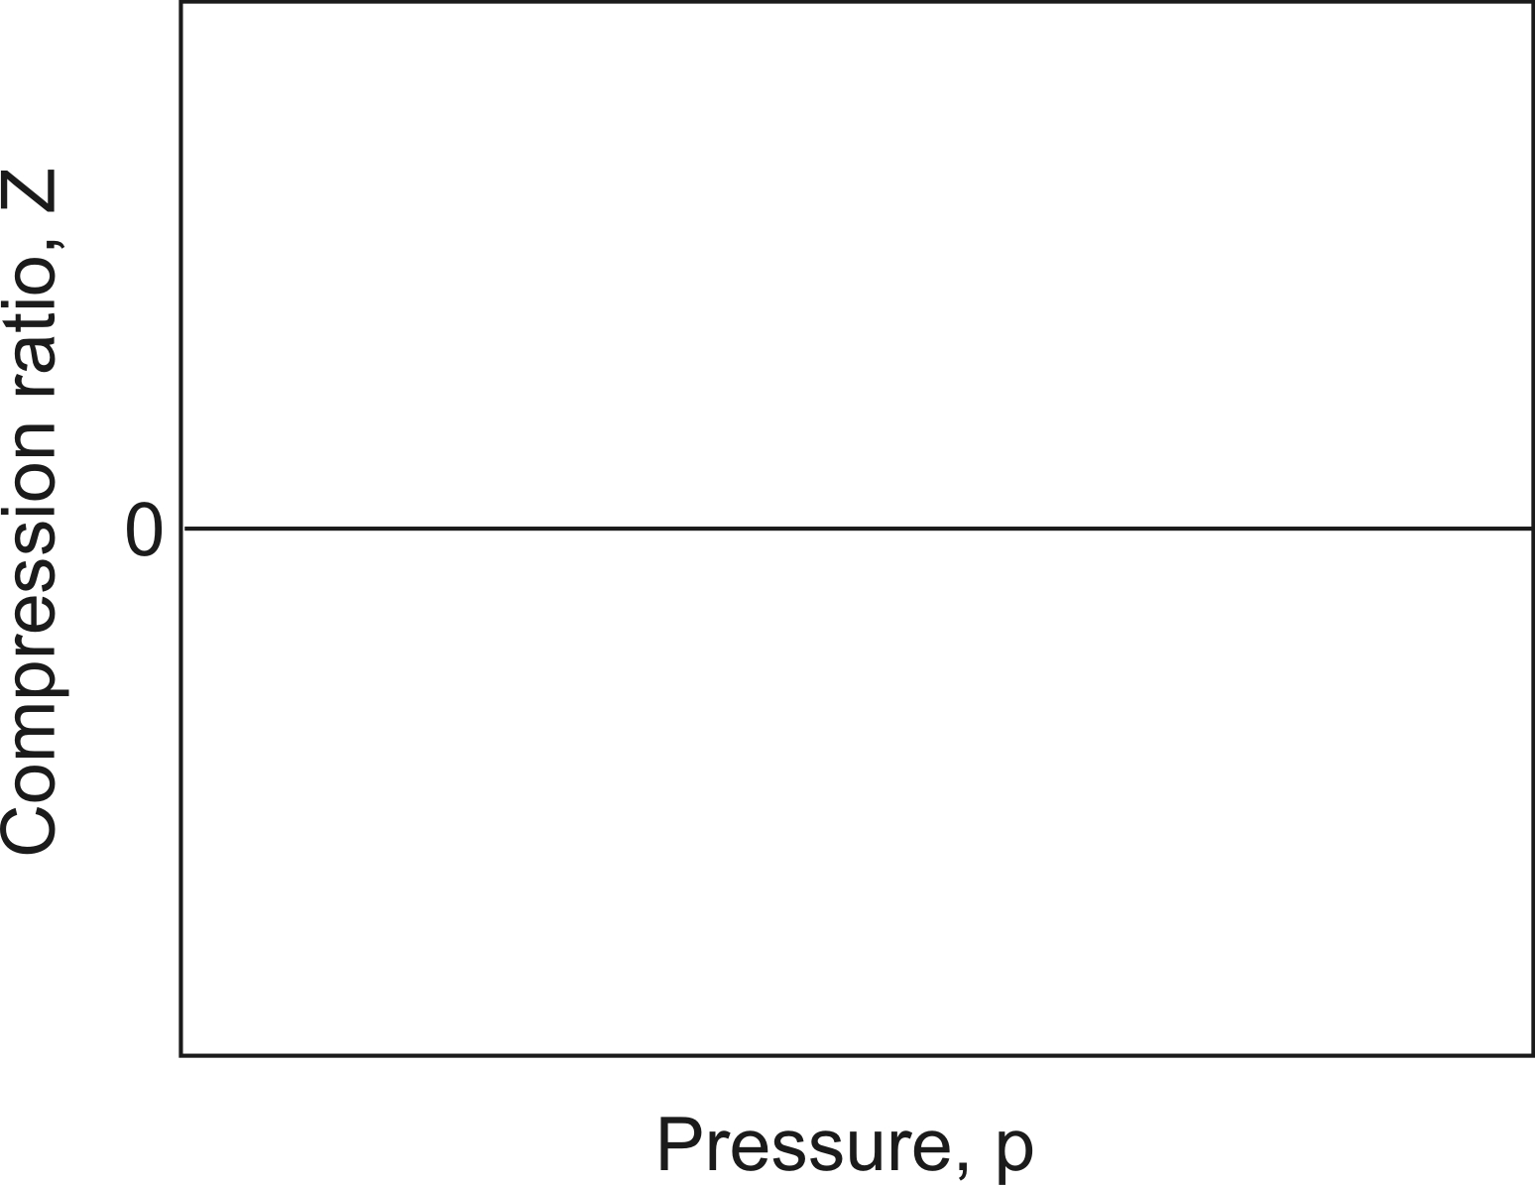

- Coal gasification
In the process of coal gasification coal is converted into a combustible mixture of carbon monoxide and hydrogen, called coal gas
H₂O (g) + C (s) → CO (g) + H₂ (g)
- Calculate the standard enthalpy change for this reaction from the following chemical equations and standard enthalpy changes
2C (s) + O₂ (g) → 2 CO (g) Δ_{r}H° = –221.0 kJ mol^{–1}
2H₂ (g) + O₂ (g) → 2 H₂O (g) Δ_{r}H° = –483.6 kJ mol^{–1}
The coal gas can be used as a fuel :
CO (g) + H₂ (g) + O₂ (g) → CO₂ (g) + H₂O (g)
- Given the additional information, calculate the enthalpy change for this combustion
C (s) + O₂ (g) → CO₂ (g) Δ_{r}H° = –393.5 kJ mol^{–1}
Coal gas can also undergo the process of methanation.
3H₂ (g) + CO (g) → CH₄ (g) + H₂O (g)
- Determine the standard enthalpy change for the methanation reaction using the additional data.
CH₄ (g) + 2O₂ (g) → CO₂ (g) + 2 H₂O (g) Δ_{r}H° = –802.7 kJ mol^{–1}
- The industrial preparation of hydrogen
Hydrogen gas may be prepared industrially by heating hydrocarbons, such as a methane, with steam:
CH4 (g) + H₂O (g) 3H₂ (g) + CO (g) A
- Given the following thermodynamic data, calculate the Δ_{r}G° for reaction A at 298 K and hence a value for the equilibrium constant, Kp.
 | ΔfH° (298) / kJ mol–1 | S° (298) / J K–1 mol–1
CH4 (g) | –74.4 | 186.3
H2O (g) | –241.8 | 188.8
H2 (g) |  | 130.7
CO (g) | –110.5 | 197.7
- How will the equilibrium constant vary with temperature?
The industrial preparation can be carried out at atmospheric pressure and high temperature, without a catalyst. Typically, 0.2 vol % of methane gas remains in the mixture at equilibrium.
- Assuming the reaction started with equal volumes of methane and steam, calculate the value of K_{p} for the industrial process which gives 0.2 vol % methane at equilibrium.
- Use your answer from (c) together with the integrated form of the van’t Hoff isochore to estimate the temperature used in industry for the preparation of hydrogen from methane.
- The bonds in dibenzyl
This question is a typical application of thermodynamic cycles to estimate a bond dissociation enthalpy.
The first step in the pyrolysis of toluene (methylbenzene) is the breaking of the C₆H₅CH₂–H bond. The activation enthalpy for this process, which is essentially the bond dissociation enthalpy, is found to be 378.4 kJ mol^{–1}.
- Write a balanced equation for the complete combustion of toluene.
Standard enthalpies are given below, using the recommended IUPAC notation (i.e. f = formation, c = combustion, vap = vaporisation, at = atomisation)
Δ_{f}H°(CO₂, g, 298K) = –393.5 kJ mol^{–1}
Δ_{f}H°(H₂O, l, 298K) = –285.8 kJ mol^{–1}
Δ_{c}H°(C₇H₈, l, 298K) = –3910.2 kJ mol^{–1}
Δ_{vap}H°(C₇H₈, l, 298K) = +38.0 kJ mol^{–1}
Δ_{at}H°(H₂, g, 298K) = +436.0 kJ mol^{–1}.
  - Calculate Δ_{f}H°(C₇H₈, l, 298K)
  - Estimate Δ_{f}H° for the benzyl radical C₆H₅CH₂·(g) at 298 K.
- The standard entropy of vaporisation of toluene is 99.0 J K^{–1} mol^{–1}.
  - Calculate Δ_{vap}G° for toluene at 298 K.
  - What is the reference state of toluene at 298 K?
  - Calculate the normal boiling point of toluene.
- The standard enthalpy of formation of dibenzyl (1,2–diphenylethane) is 143.9 kJ mol^{–1}. Calculate the bond dissociation enthalpy for the central C–C bond in dibenzyl, C₆H₅CH₂–CH₂C₆H₅.
- Interstellar chemistry
A possible ion–molecule reaction mechanism for the synthesis of ammonia in interstellar gas clouds is shown below
N⁺ + H₂ → NH⁺ + H k₁
NH⁺ + H₂ → NH₂⁺ + H k₂
NH₂⁺ + H₂ → NH₃⁺ + H k₃
NH₃⁺ + H₂ → NH₄⁺ + H k₄
NH₄⁺ + e– → NH₃ + H k₅
NH₄⁺ + e– → NH₂ + 2H k₆
- Use the steady state approximation to derive equations for the concentrations of the intermediates NH⁺, NH₂⁺, NH₃⁺ and NH₄⁺ in terms of the reactant concentrations [N⁺], [H₂] and [e–]. Treat the electrons as you would any other reactant.
- Show that the overall rate of production of NH₃ is given by
$$\frac{d[{\text{NH}}_{3}]}{dt}=k_{\text{2nd}}[N^{+}][H_{2}]$$
where k_{2nd} is the second order rate constant for the reaction. Give an expression for k_{2nd} in terms of the rate constants for the elementary steps, k₁ to k₆.
- What is the origin of the activation energy in a chemical reaction?
The rates of many ion-molecule reactions show virtually no dependence on temperature.
- What does this imply about their activation energy?
- What relevance does this have to reactions occurring in the interstellar medium?
- Simple collision theory
For the elementary gas phase reaction H + C₂H₄ → C₂H₅, the second-order rate constant varies with temperature in the following way:
T / K | 198 | 298 | 400 | 511 | 604
k × 10¹² / cm³ molecule^{–1} s^{–1} | 0.20 | 1.13 | 2.83 | 4.27 | 7.69
- Use the data to calculate the activation energy, E_{a}, and the pre-exponential factor, A, for the reaction.
The simple collision theory of bimolecular reactions yields the following expression for the rate constant:
$$k=σ\sqrt{\frac{8k_{B}T}{\text{πμ}}}\text{exp}\left(−\frac{E_{a}}{\text{RT}}\right)$$
where μ is the reduced mass of the reactants and σ is the reaction cross section.
- Interpret the role of the three factors in this expression; σ, the exponential, and the square-root term.
- Use the answer to part (a) to estimate σ for the reaction at 400 K.
- Compare the value obtained with an estimate of 4.0 × 10^{–19} m² for the collision cross section.
- Hinshelwood
Sir C.N. Hinshelwood shared the 1956 Nobel prize in Chemistry for his work on the mechanisms of high temperature reactions.
- The pyrolysis of ethanal proceeds by the following simplified mechanism:
reaction | rate constant | E_{a} / kJ mol^{–1}
CH₃CHO → CH₃· + HCO· | k₁ | 358
CH₃· + CH₃CHO → CH₄ + CH₃CO· | k₂ | 8
CH₃CO· → CH₃· + CO | k₃ | 59
HCO· → H· + CO | k₄ | 65
H· + CH₃CHO → H₂ + CH₃CO· | k₅ | 15
2CH₃· → C₂H₆ | k₆ | 0
- List each reaction as initiation, propagation or termination.
- Use the steady-state approximation on the radical intermediates to find expressions for the steady-state concentrations of the HCO, H, CH₃ and CH₃CO radicals.
- Find rate laws for the rate of loss of ethanal, and the rates of formation of methane, ethane, hydrogen and CO.
- There are two pathways for the dissociation of ethanal. Write a balanced equation for each reaction and for each find the order with respect to ethanal, and the activation energy.
- Enzyme kinetics
Characterisation of enzyme kinetics can play an important role in drug discovery. A good understanding of how the enzyme behaves in the presence of its natural substrate is necessary before the effect of potential drugs can be evaluated. Enzymes are typically characterised by two parameters, V_{max} and K_{m}; these are determined by analysing the variation of the initial rate of reaction with substrate concentration.
Many enzymatic reactions can be modelled using the scheme:
E + S → ES rate constant k₁
ES → E + S rate constant k_{–1}
ES → E + P rate constant k₂
where E is the free enzyme, S is the substrate, ES is a complex formed between the enzyme and substrate and P is the product.
- Assuming that the system is in steady state and that [S] >> [E] obtain an expression
  - for the rate of production of ES in terms of [E], [S], [ES] and the appropriate rate constants.
  - for the rate of production of P in terms of [ES] and the appropriate rate constants.
When doing the experiment [E] is not known, however the total amount of enzyme present is constant throughout the reaction, therefore:
[E]₀ = [E] + [ES]
where [E]₀ is the initial enzyme concentration.
Also, in enzyme kinetics the Michaelis constant, K_{m}, is defined as:
K_{m} = (k_{–1} + k₂) / k₁
- Obtain an expression for [ES] in terms of [S], [E]₀ and K_{m}.
- Hence obtain an expression for the rate of production of P in terms of [E]₀, [S] and the appropriate constants.
The maximal rate of reaction, V_{max}, occurs when all of the enzyme molecules have substrate bound, i.e. when [ES] = [E]₀, therefore:
V_{max} = k₂ × [E]₀
- Obtain an expression for the rate of production of P in terms of V_{max}, [S] and the appropriate constants.
The enzyme GTP cyclohydrolase II catalyses the first step in riboflavin biosynthesis in bacteria:
The absence of this enzyme in higher organisms makes GTP cyclohydrolase II a potential target for antimicrobial drugs.
Protein samples were rapidly mixed with different concentrations of GTP. The change in absorbance with time was measured at 299 nm in a 1 ml cell with a 1 cm pathlength. A 100 μM solution of the purified product gave an absorbance of 0.9 in a 1 cm pathlength cell at 299 nm.
Time / s | GTP concentration
 | 200 μΜ | 150 μΜ | 100 μΜ | 80 μΜ | 60 μΜ | 40 μΜ | 20 μΜ
6 | 0.00514 | 0.00469 | 0.00445 | 0.00393 | 0.00377 | 0.00259 | 0.00197
7 | 0.00583 | 0.00547 | 0.00477 | 0.00454 | 0.00388 | 0.00253 | 0.00247
8 | 0.00708 | 0.00639 | 0.00568 | 0.00506 | 0.00452 | 0.00309 | 0.00253
9 | 0.00698 | 0.00703 | 0.00639 | 0.00591 | 0.00521 | 0.00325 | 0.00295
10 | 0.00818 | 0.00800 | 0.00709 | 0.00645 | 0.00574 | 0.00387 | 0.00302
11 | 0.00901 | 0.00884 | 0.00752 | 0.00702 | 0.00638 | 0.00445 | 0.00352
12 | 0.0103 | 0.00922 | 0.00849 | 0.00771 | 0.00707 | 0.00495 | 0.00386
- Calculate the initial rate of reaction at each of the GTP concentrations.
- Express the equation obtained in part (d) in the form y = mx + c.
- Hence determine V_{max} and K_{m} for this enzyme (you may assume that the kinetic scheme outlined above is valid for this enzyme)
- Hydrocyanic acid
Hydrocyanic acid is a weak acid with dissociation constant K_{a} = 4.93×10^{–10}
- Find the pH of a 1.00 M solution of HCN.
- 10 L of pure water is accidentally contaminated by NaCN. The pH is found to be 7.40. Deduce the concentrations of each of the species, Na⁺, H⁺, OH–, CN–, HCN, and hence calculate the mass of NaCN added.
- Chlorine electrochemistry
- State the Nernst equation.
- You are given the following set of standard electrode potentials and half cell reactions for chlorine.
Alkaline | E°/ V | Acidic | E°/ V
 | 0.37 |  | 1.20
 | 0.30 |  | 1.19
 | 0.68 |  | 1.67
 | 0.42 |  | 1.63
 | 1.36 |  | 1.36
Calculate the following quantities
  - The ionic product of water, K_{w}.
  - The equilibrium constants for the disproportionation reaction of chlorine to oxidation states +1 and –1 under both acidic and alkaline conditions.
  - The pK_{a} value for HOCl.
  - The concentrations at pH 7.5 of HOCl and ClO– in a solution where the total concentration of hypochlorite (chlorate (I)) is 0.20 mmol dm^{–3}, and the electrode potential for the reduction of this system to chlorine at this pH with unit activity of chlorine. These conditions are typical of a swimming pool.
- The solubility of CuBr
The EMF of the cell
Pt | H₂ (g) (p =1.0 bar) | HBr (aq) (1.0×10⁻⁴ M) | CuBr | Cu
is 0.559 V at 298 K. (Assume that all species in the cell behave ideally).
- Write down half cell reactions for the right and left hand electrodes, the Nernst equation for the cell and the standard electrode potential for the CuBr electrode.
- The standard electrode potential for the Cu/Cu⁺ (aq) couple is 0.522 V. Calculate ΔG° for the dissolution of CuBr at 298 K and hence the solubility product of CuBr.
- Calculate the concentration of Cu⁺ (aq) ions in the cell shown above.
- By how much would the EMF of the cell change if the pressure of hydrogen were doubled?
- Electrochemical equilibria
- Calculate the standard electrode potential for the aqueous couple [Fe(CN)₆]^{3–} / [Fe(CN)₆]^{4–} from the following data:
E°(Fe³⁺(aq) | Fe²⁺(aq)) = + 0.770 V
Fe³⁺(aq) + 6CN–(aq) [Fe(CN)₆]^{3–}(aq) log10 K_{c} = 43.9
Fe²⁺(aq) + 6CN–(aq) [Fe(CN)₆]^{4–}(aq) log10 K_{c} = 36.9
The following standard electrode potentials have been reported:
In⁺(aq) + e– In(s) E° = – 0.13 V
In³⁺(aq) + 3e– In(s) E° = – 0.34 V
Tl⁺(aq) + e– Tl(s) E° = – 0.34 V
Tl³⁺(aq) + 3e– Tl(s) E° = + 0.72 V
- Calculate the equilibrium constant for the disproportionation reaction
3M⁺ (aq) → M³⁺ (aq) + 2M (s) for In and Tl. Comment on the result.
- Photodissociation of Cl₂
Photodissociation is the process in which a molecule fragments after absorbing a photon with sufficient energy to break a chemical bond. The rupture of a chemical bond is one of the most fundamental chemical processes, and has been studied in great detail.
In a modified time-of-flight mass spectroscopy technique for studying Cl–Cl bond cleavage, a laser beam is crossed with a molecular beam of Cl₂, and dissociation occurs at the crossing point. A second laser beam ionises the resulting Cl atoms (without affecting their velocities), so that a carefully tuned electric field may be used to guide them along a 40 cm flight path to a position sensitive detector.
The image of the Cl fragments recorded at the detector is shown on the right. Note that this represents a two-dimensional projection of the full three-dimensional velocity distribution. | 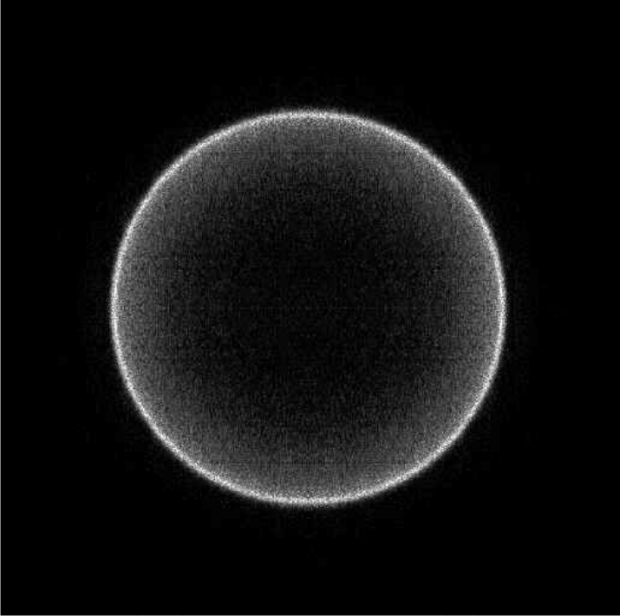
- A potential of 3000 V is used to direct the ionised Cl atoms to the detector. What is their flight time? Take the mass of a Cl atom to be 35 g mol^{–1}.
- The image appears as a single ring of Cl atoms as a result of conservation of energy and momentum. The outside diameter of the ring is 12.68 mm. What velocity did the Cl atoms acquire as a result of the photodissociation?
- The bond dissociation energy of Cl₂ is 243 kJ mol^{–1}. Use conservation of energy to determine the laser wavelength.
- Laser Cooling
This question is about laser cooling, which is a quick and efficient way of cooling ions down to very cold temperatures. The mean kinetic energy of a molecule is related to its temperature by $E=\frac{3}{2}k_{B}T$, where k_{B} is the Boltzmann constant.
- Calcium atoms leak out of an oven at 600 °C. Calculate the mean kinetic energy of the calcium atoms and hence the rms momentum and rms speed of a ⁴⁰Ca atom, whose relative isotopic mass is 39.96.
- The atoms drift into an ion trap where they are photoionised and trapped. While in this trap they are bombarded with laser light of wavelength 396.96 nm. Calculate the frequency, energy and momentum of a photon with this wavelength.
- The ions go through an optical cycle repeatedly. Ions absorb a photon from the laser when they are moving in the opposite direction to the light (this is achieved using the Doppler Effect) and then re-emit a photon in a random direction. The net effect of this procedure is to slow the ion down slightly. Calculate the change in mean momentum and speed at each cycle and the number of photons that would need to be absorbed to bring the ion approximately to rest. (In practice this process was found to reduce the temperature to about 0.5 mK.)
- Write down the ground electronic configuration of the Ca⁺ ion, and calculate the orbital and spin angular momentum of the unpaired electron.
- In the excited configuration involved in the laser cooling transition the unpaired electron has been excited into the lowest available p orbital. Calculate the orbital and spin angular momentum of the unpaired electron.
- In this excited state the electron experiences a magnetic field because of its own orbital motion around the charged nucleus. The spin of the electron can line up either parallel or antiparallel to this field, and the two states have slightly different energies. The resultant quantum number, j, for the total electronic angular momentum takes values from $\left|l−s\right|$ to $\left|l+s\right|$ in integer steps. Calculate the possible values of j.
- The laser cooling transition is to the lower of these two levels, the transition from the ground state to the higher level has a wavelength 393.48 nm. Calculate the energy difference between the two levels resulting from the excited configuration.
- Hydrogen bond strength determination
In an experiment to measure the strength of the intramolecular hydrogen-bond in B, the chemical shift of the amide proton δ_{obs}, was measured at various temperatures.
T / K | δ_{obs} / ppm
220 | 6.67
240 | 6.50
260 | 6.37
280 | 6.27
300 | 6.19
The observed chemical shift, δ_{obs}, is the weighted average of the shifts of the N–H proton when the amide is completely hydrogen bonded, δ_{h}, and when it is completely free, δ_{f}.
- Derive an expression for the observed chemical shift of the N–H proton, δ_{obs}.
- Derive an expression for the equilibrium constant K for A B in terms of δ_{obs}, δ_{h}, and δ_{f}.
- Given that δ_{h} = 8.4 ppm and δ_{f} = 5.7 ppm, calculate the equilibrium constants for the cyclisation at the different temperatures.
- By plotting a suitable graph, determine the standard enthalpy change for A → B and the standard change in entropy at 300 K.
- Discuss the significance of your answers to part (b).
- Magnetic Complexes
Reaction of FeCl₂ with phenanthroline (phen) and two equivalents of K[NCS] yields the octahedral iron (II) complex Fe(phen)₂(NCS)₂ (A). At liquid nitrogen temperature A has a magnetic moment of 0.0 B.M. but a magnetic moment near 4.9 B.M. at room temperature. [The effective magnetic moment, μ_{eff}, for a complex containing n unpaired electrons is given by: μ_{eff} = $\sqrt{n(n+2)}$ Bohr magnetons, B.M.]
Phenanthroline
- Draw structures of the possible isomers of A
- Determine the number of valence electrons which occupy the d-orbitals of A
- Draw electronic configurations for the d-orbital occupancy consistent with the high temperature and low temperature magnetic behaviour of A [You should determine the expected effective magnetic moment in each case]
- Which of the following statements is/are consistent with the low temperature magnetic data:
YES NO INSUFFICIENT DATA
Hund’s Rules are obeyed □ □ □
The Pauli Exclusion Principle is obeyed □ □ □
- Which of the following statements is/are consistent with the high temperature magnetic data:
YES NO INSUFFICIENT DATA
Hund’s Rules are obeyed □ □ □
The Pauli Exclusion Principle is obeyed □ □ □
The ligand Hacac (B, C₅H₈O₂) is shown below. Treatment with NH₃ yields the anion acac– (C) whose C–O bond lengths are longer than those in B and whose ¹H NMR exhibits just two peaks. Addition of three equivalents of acac– to an aqueous solution of FeCl₃ yields a bright red octahedral complex (D) of composition C₁₅H₂₁O₆Fe with an effective magnetic moment of 5.9 B.M.
Hacac
- Draw the anion acac– (C) and determine a resonance structure to explain the difference in C–O bond lengths between B and C.
- Draw the structures of B and C and clearly label the hybridisation state at each carbon in each case.
- Draw possible isomers of D and predict the d-orbital occupancy in light of the observed magnetic data.
- Explosive S₄N₄
Bubbling gaseous NH₃ through a solution of SCl₂ generates a red explosive solid, S₄N₄. Its structure can be represented in a number of ways; one way is as shown below.
- Write a balanced equation for the formation of S₄N₄ from NH₃ and SCl₂
- Construct a Born-Haber cycle for the formation of S₄N₄ and use the data below to determine the enthalpy of formation of S₄N₄
- Use the additional data and your answer to part (a) to determine the enthalpy change for the reaction of NH₃ with SCl₂
The S₄N₄ molecule has a rich reaction chemistry including both oxidation and reduction reactions. Treatment of S₄N₄ with an excess of AsF₅ in sulfur dioxide generates the salt [S₄N₄][AsF₆]₂ whereas treatment with excess SnCl₂·2H₂O in methanol yields S₄N₄H₄
- Write balanced equations for these two reactions
E(S–S) = 226 kJ mol^{–1} E(N≡N) = 946 kJ mol^{–1}
E(S–N) = 273 kJ mol^{–1} E(S=N) = 328 kJ mol^{–1}
ΔH_{vap}(S₈) = 77 kJ mol^{–1} ΔH_{vap}(S₄N₄) = 88 kJ mol^{–1}
Δ_{f}H (NH₃) = – 45.9 kJ mol^{–1} Δ_{f}H (SCl₂) = – 50.0 kJ mol^{–1}
Δ_{f}H (HCl) = – 92.3 kJ mol^{–1}
- Sulfur compounds
Identify the compounds A to D in the scheme shown below and describe their structures with the aid of suitable sketches.
You may wish to refer to the following additional information :
Compound A is a yellow liquid containing 52.5% Cl and 47.5% S.
Compound B is a moisture-sensitive, red liquid.
Compound C is a colourless liquid containing 59.6% Cl, 26.95% S and 13.45% O.
Compound D has a relative molar mass of 134.96 g mol^{–1}. Compound D can also be obtained by direct reaction of C with O₂.
- Reactions of sodium
The scheme below summarises some reactions of sodium metal.
- Compound A is white, crystalline solids. Identify it and discuss the bonding in the anion. How do the metals Li and K react with excess O₂?
- Compounds B and C are both deeply coloured solids. Identify each of them and briefly discuss the driving force for their formation. Note that the EtNH₂ acts only as a solvent for these reactions.
- Solutions of D and E are deep green and blue, respectively. What are the species present in these solutions?
- Compound G is a white crystalline ionic solid, while F is a colourless, highly flammable gas that does not condense in liquid NH₃. Identify F and G.
- Compound H is a white, ionic solid. One mole of the gas F is formed for each mole of H that is formed. Identify compound H.
- Chlorine compounds
Compounds A to I all contain chlorine.
- Identify A to I and write balanced equations for the following reactions:
- Predict the structures of B, D, F and H, and comment on points of interest in the structure of H
- Comment on the conditions used in the sequence of reactions:
- Perkin Junior
Sir William Henry Perkin accidentally discovered “mauveine”, the first commercial synthetic dyestuff, in 1856 while working in his home laboratory. His love of chemistry was passed on to his eldest son William Henry Perkin, Jr. (1860-1929). William Henry Perkin Jr is best known for his work on the synthesis and structure elucidation of natural products including α-terpineol. Perkin’s synthesis of this monoterpene forms the basis of this question.
As Perkin stated, the synthesis of α-terpineol (F) “was undertaken with the object of synthesising…terpineol…, not only on account of the interest which always attaches to syntheses of this kind, but also in the hope that a method of synthesis might be devised of such a simple kind that there would no longer be room for doubt as to the constitution of these important substances”.
We begin Perkin’s synthesis of α-terpineol with the ketone A.
- Identify the intermediates B, C, D and E.
- What reagent would you use to convert E into α-terpineol F.
- Suggest reagents for the preparation of A from 4-hydroxybenzoic acid.
α-Terpineol F has been used to prepare other monoterpenes.
- Treatment of α-terpineol F with potassium hydrogen sulfate gave compound G which reacts with two equivalents of bromine. Identify G given that it is chiral.
- Treatment of α-terpineol F with aqueous acid gives compound H. Exposure of H to stronger acid gives I. Identify H and I.
In the ¹H NMR spectrum of H addition of D₂O results in the disappearance of one signal corresponding to two hydrogens, whereas the ¹H NMR spectrum of compound I remains unchanged on addition of D₂O.
Neither compound H nor I are chiral, and neither react with bromine.
- Cyclooctatetraene
Cyclooctatetraene H was an exceedingly important molecule in the development of the theory of organic chemistry. It belongs to a class of compounds which, although they have alternating single and double bonds in a ring, do not benefit from the increase in stability that aromatic compounds such as benzene do. Cyclooctatetraene was first synthesised by Willstätter starting from the natural product pseudopelletierine A, according to the scheme below; in 1940 Reppe reported a one step synthesis of cyclooctatetraene from acetylene thus making this previously precious laboratory chemical into a commercially available material.
- Identify intermediates B, C, and D
- Suggest reagents for the conversion of D into E, E into F, F into G and G into cyclooctatetraene.
Pseudopelletierine A is a natural product found in the bark of the pomegranate. Biochemical labelling studies have shown that it is biosynthesised from lysine W, and ethanoate via Δ¹–piperideine X, pelletierine Y and N-methylpelletierine Z.
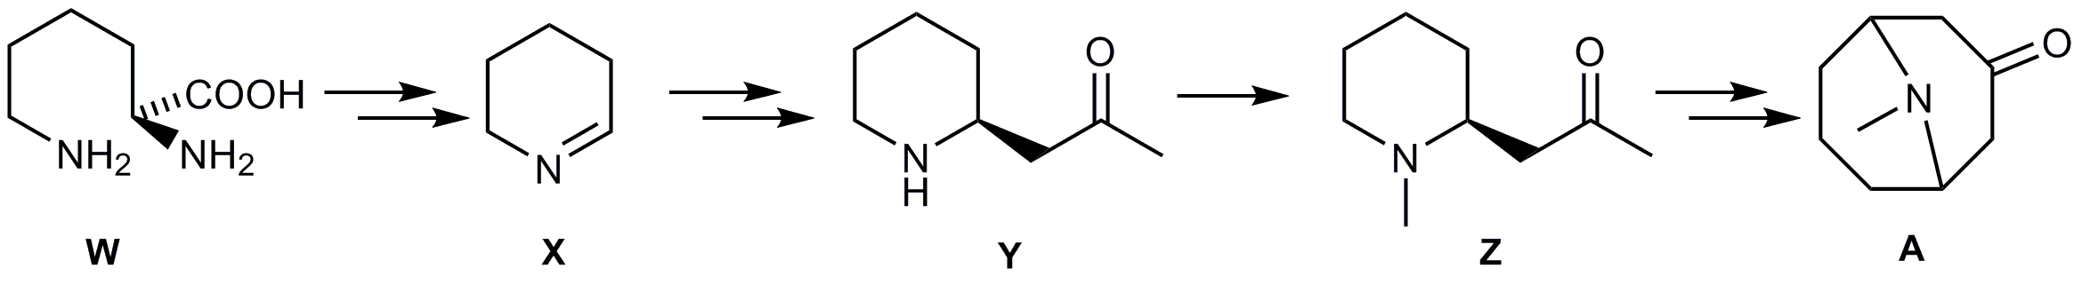
The route by which pelletierine is formed from Δ¹–piperideine and ethanoate was determined using ¹³C labelling studies. Four possible routes can be postulated:
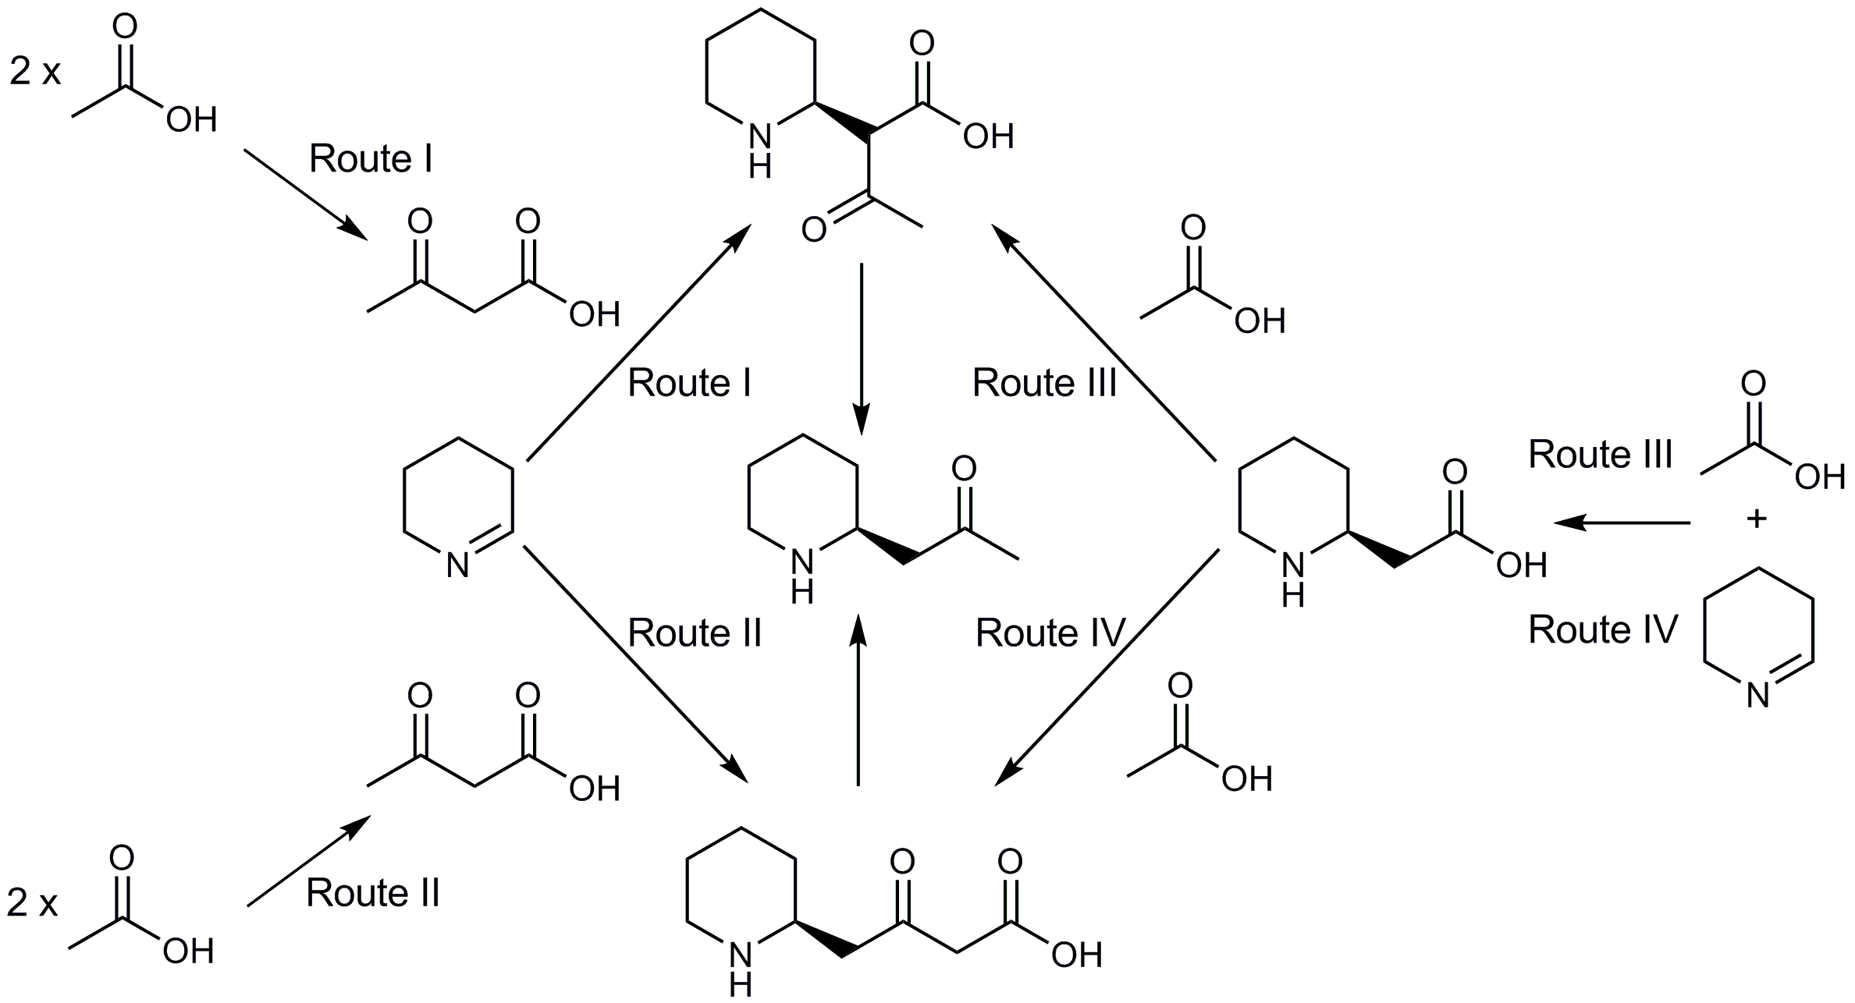
To distinguish between the different biosynthetic routes two experiments were carried out. In the first experiment plants were fed a mixture of sodium ethanoate labelled with ¹³C at both carbon positions (sodium [1,2-¹³C₂]ethanoate) and the unlabelled compound (a mixture was used to increase the probability that only a single labelled ethanoate molecule would be incorporated into each molecule of pelletierene).
- Draw structures of pelletierine indicating the position at which ¹³C labels would appear in each of the biosynthetic routes. You may assume that in each case only one of the incorporated ethanoate molecules was ¹³C labelled.
- Which biosynthetic routes can be distinguished in this experiment?
In a second experiment plants were fed a mixture of sodium 3-oxobutanoate labelled with ¹³C at all carbon positions (sodium [1,2,3,4-¹³C₄]3-oxobutanoate) and the unlabelled compound.
- Which biosynthetic routes can be distinguished in this experiment?
N-methylpelletierene was isolated from plants grown in each of the experiments and also from plants grown in presence of compounds with a natural abundance of ¹³C (the control experiment). The ¹³C NMR spectrum of each of the samples was recorded.
In N-methylpelletierene isolated from the control experiment atoms labelled j, k and l in the structure shown have ¹³C NMR chemical shifts of 31.0, 207.8 and 47.1 respectively. Each of these peaks is a singlet. | 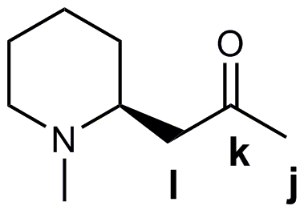
These peaks also appear in the spectra of N-methylpelletierene isolated in experiments 1 and 2, however there are also the following additional peaks:

Experiment 1 |  |  |  | Experiment 2
¹³C shift (ppm) | Multiplicity | Coupling constant (Hz) |  | ¹³C shift (ppm) | Multiplicity | Coupling constant (Hz)
31.0 | doublet | 40.4 ± 1.8 |  | 31.0 | doublet of doublets | 39.8 ± 1.8  14.4 ± 1.8
207.8 | doublet | 39.5 ± 1.8 |  | 47.1 | doublet of doublets | 39.4 ± 1.8  13.7 ± 1.8
 |  |  |  | 208.7 | doublet of doublets | 39.4 ± 1.8  39.5 ± 1.8
- Which route does the biosynthesis of pelletierene follow?
- The synthesis of methadone
Methadone
Methadone is an analgesic drug with a similar activity to morphine and is used in treating heroin addicts. It may be prepared as its hydrochloride salt by the following multi-stage synthesis:
Intermediate C is a chloride salt and may be prepared by treating two isomeric compounds with SOCl₂ and then heating up the reaction mixture:
- Deduce the structures for the compounds V, W and X.
- Deduce the structures for the compounds A, B and hence for the intermediate C.
- Deduce the structures for the compounds Y, Z and methadone hydrochloride.
- Assign, as fully as possible, the ¹H NMR spectrum of methadone.
¹H NMR δ 7.40–7.30 (10H, m), 2.78 (1H, dqd, 10.6 Hz, 6.2 Hz, 2.3 Hz), 2.49 (2H, q, 6.8 Hz), 2.26 (6H, s), 2.22 (1H, dd, 11.5 Hz, 10.6 Hz), 2.00 (1H, dd, 11.5 Hz, 2.3 Hz), 1.10 (3H, d, 6.2 Hz), 1.05 (3H, t, 6.8 Hz).
The synthesis above yields a racemic mixture. In order to obtain the pure, biologically active (R)-enantiomer resolution may be achieved by crystallisation with (+)–tartaric acid.
- Draw the structure of the biologically active enantiomer of methadone.
- Verapamil
Verapamil is a calcium channel blocker used for, among other things, the treatment of hypertension and cardiac arrhythmia. It can be prepared from the reaction between H and M which can be synthesised according to the schemes below.
- Suggest reagents for the multi-step conversion of A into the racemic acid B.
The acid B can be resolved to give the enantiopure acid C on treatment with cinchonidine.
- Suggest a reagent for the conversion of C in D.
- Suggest structures for intermediates E, F, G and H.
- Suggest a reagent for the conversion of I into J.
- Direct monomethylation of amines with MeI is generally not possible and hence amine J was converted into amine M by way of intermediates K and L. Suggest structures for K and L.
- How would you prepare the ester A from the nitrile I.
- Mass spectrometry of a peptide
Note: the structures, names, and codes of the amino acids are given in the Appendix.
Snake venom is composed of a variety of polypeptides and other small molecules. Venom polypeptides have a range of biological effects including muscle necrosis and the disruption of neurotransmission. Characterisation of the components of snake venom is important in the development of lead-compounds for the pharmaceutical industry and also in the creation of antivenins.
Tandem mass spectrometery (MS-MS) provides a rapid approach for determining the sequence of polypeptides. This involves formation of a parent ion, which is then fragmented to form other smaller ions. In peptides fragmentation often occurs at the amide bond, giving rise to so-called ‘b ions’. The b ions formed from an alanine-valine-glycine polypeptide are shown below. Remember that by convention the first amino acid is that with the free –NH₂ group.
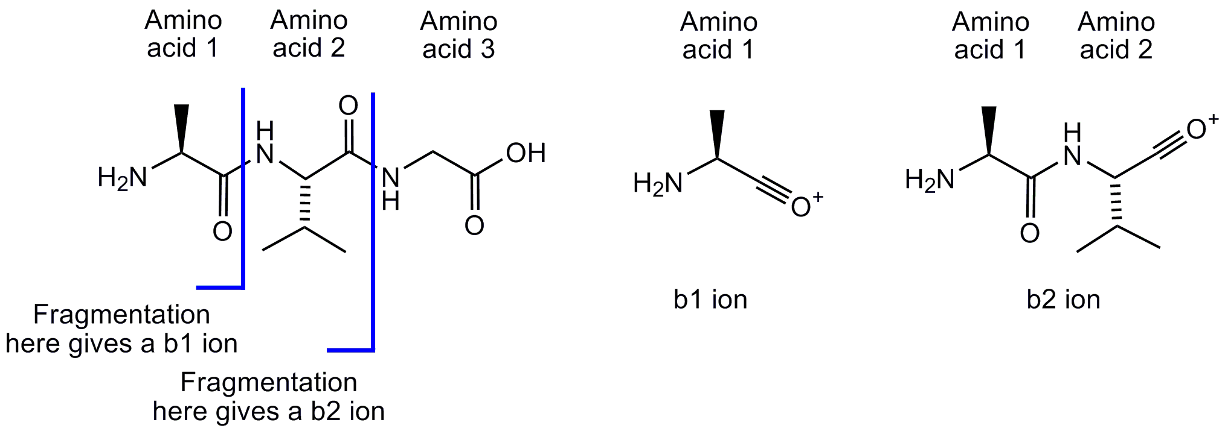
Polypeptide X was isolated from the venom of the pit viper, B. insularis. The amino acid composition of polypeptide X may be found by acid hydrolysis of the peptide. Under the conditions used for the hydrolysis, Asp and Asn are indistinguishable and are termed Asx; similarly Glu and Gln are indistinguishable and termed Glx. The composition of polypeptide X was found to be: 1 × Asx, 2 × Glx, 1 × His, 1 × Ile, 4 × Pro and 1 × Trp.
- How many unique decapeptide sequences can be formed from these amino acids:
  - assuming Glx are both the same amino acid?
  - assuming that one of the Glx amino acids is Glu, the other Gln?
- What are the possible masses for Polypeptide X?
In the mass spectrum of Polypeptide X the parent ion showed at peak at an m/z of 1196.8. It is known that although snake toxins are synthesised from the 20 common amino acids shown in the table some of these amino acids can be chemically modified after polypeptide synthesis. The mass spectrum of the parent ion suggests that one of the amino acids in Polypeptide X has been modified in a way that is not evident after acid hydrolysis.
Polypeptide X was sequenced using MS-MS. The masses of the b ions are shown in the table below:
ion | m/z | ion | m/z | ion | m/z
b₁ | 112.2 | b₄ | 509.7 | b₇ | 872.0
b₂ | 226.4 | b₅ | 646.7 | b₈ | 985.0
b₃ | 412.5 | b₆ | 743.8 | b₉ | 1082.2
- What is the sequence of Polypeptide X? You may use Mod for the modified amino acid.
- What is the mass of the modified amino acid?
The ¹³C NMR spectra of Mod in D₂O is shown on the right.  The ¹H NMR spectra, taken in an organic solvent, and in D₂O are shown below. | 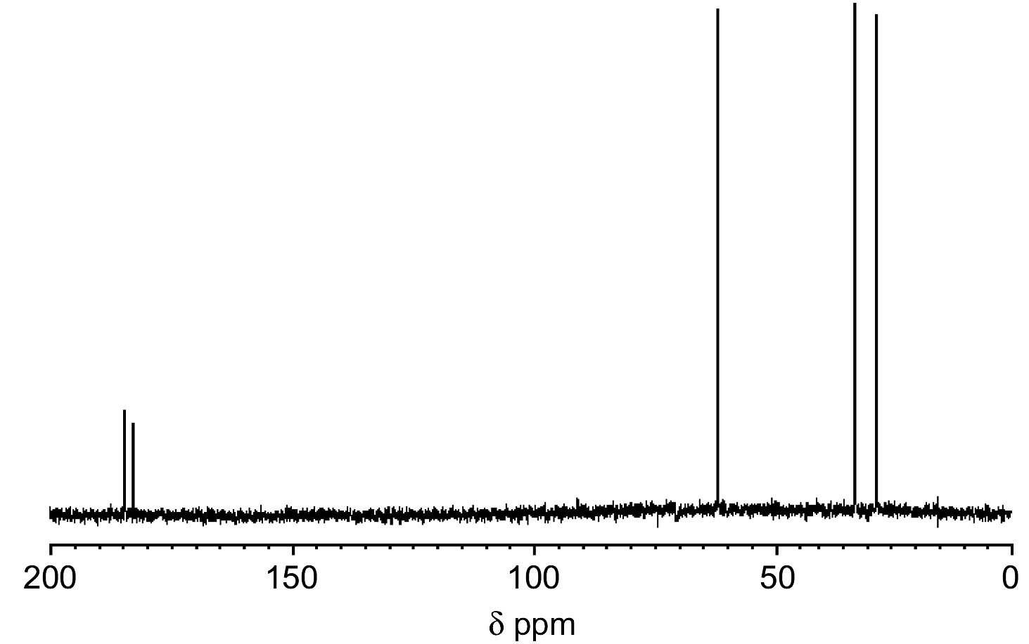
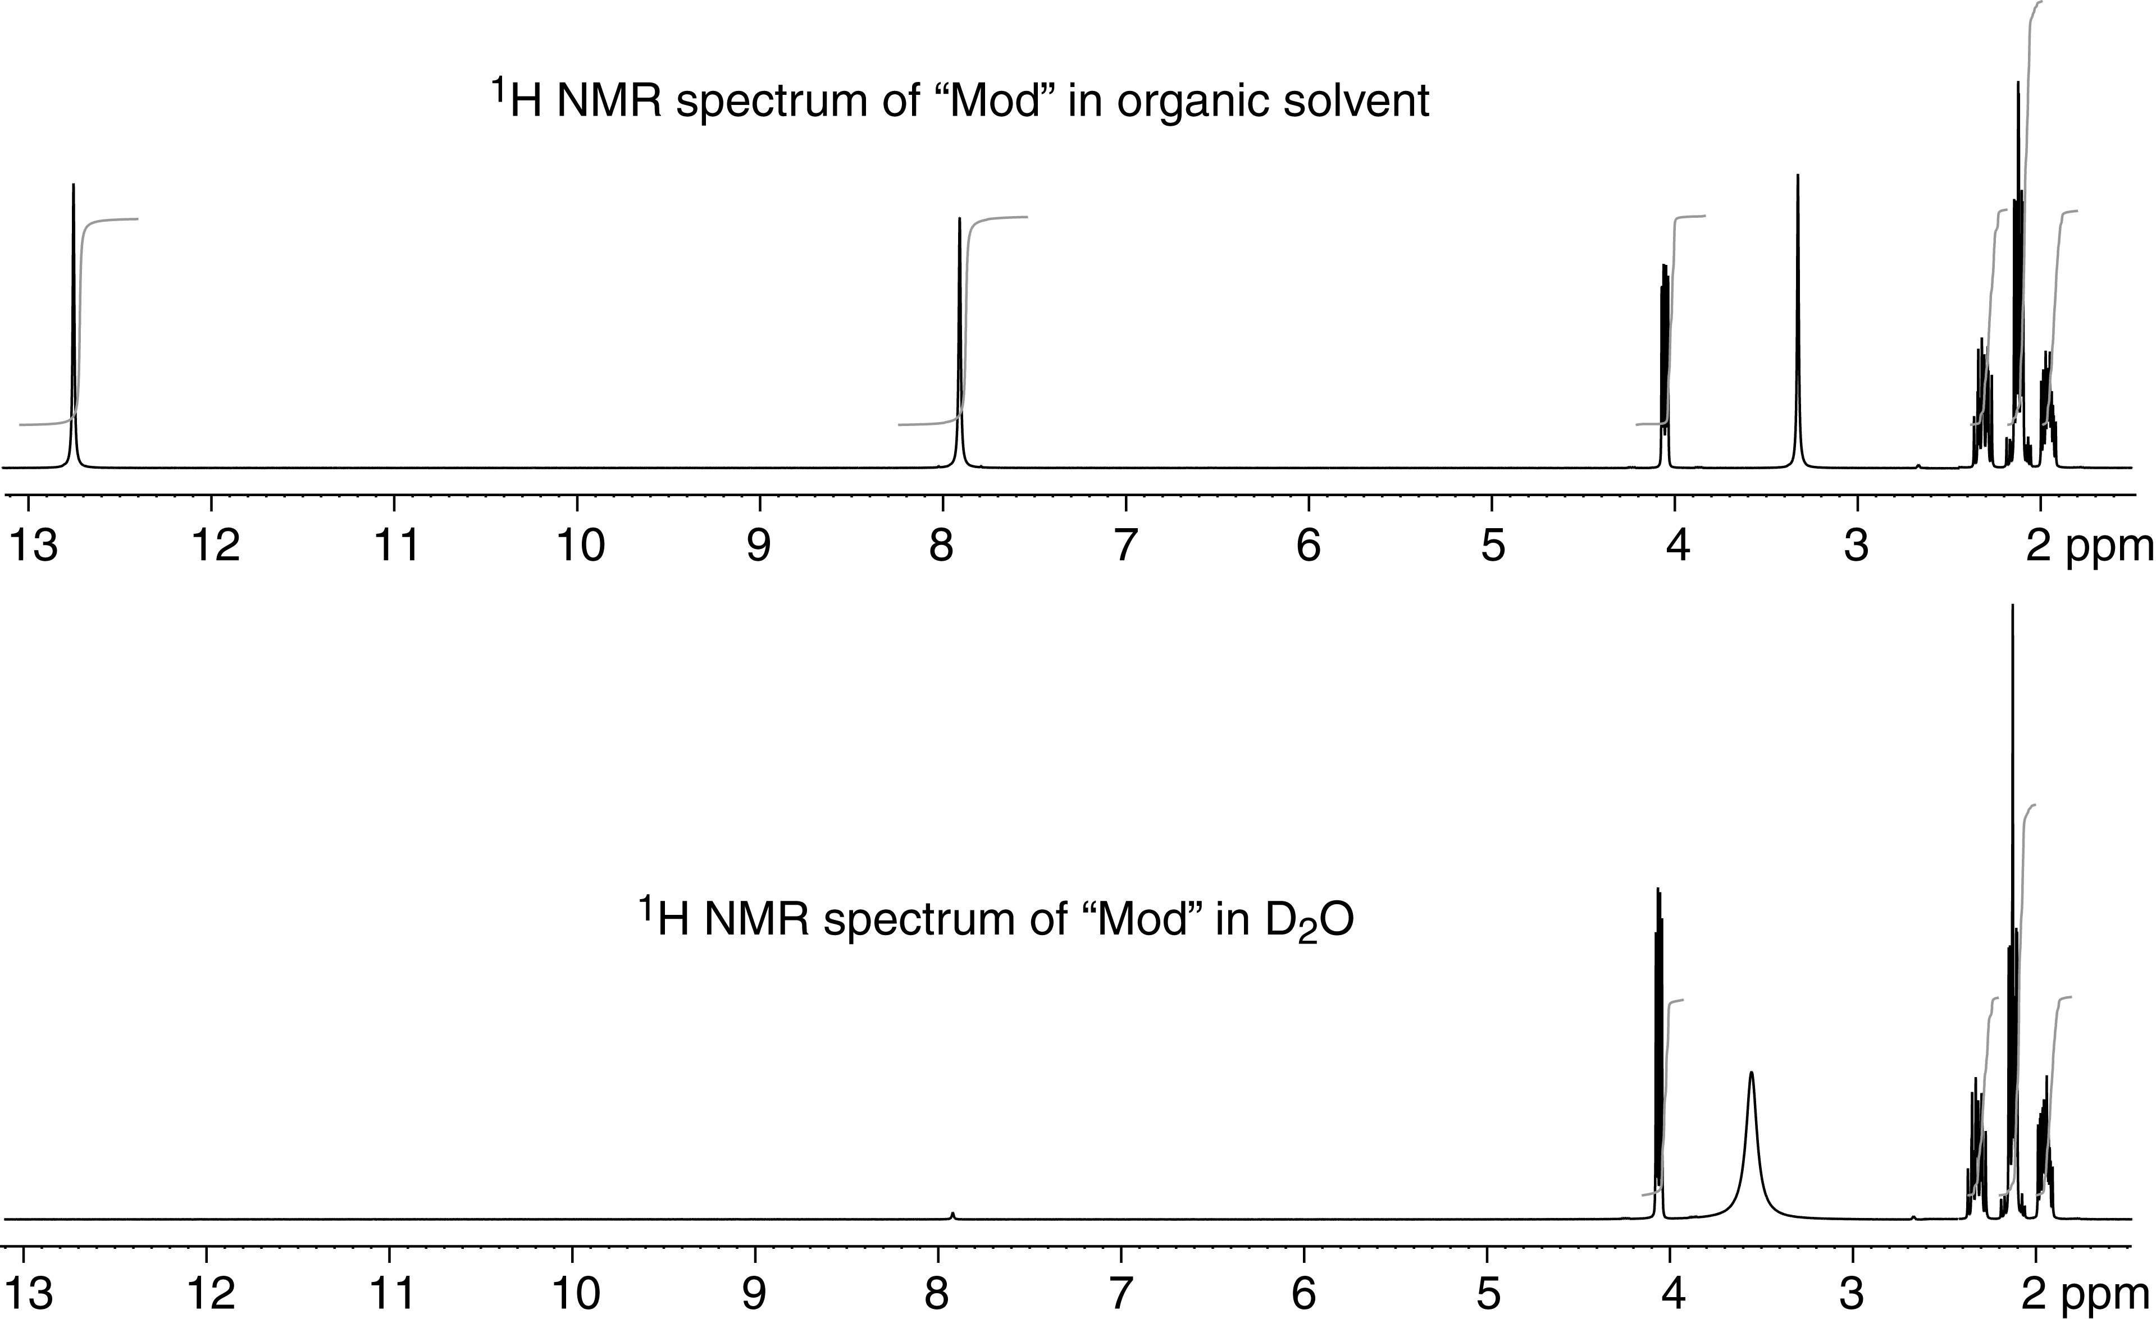
- Draw the structure of Mod and suggest which protons give rise to which signals in the ¹H NMR spectrum. You need not explain the multiplicity of the signals.
- A fossilized peptide
Note: the structures, names, and codes of the amino acids are given in the Appendix.
Tandem mass spectrometery (MS-MS) provides a rapid approach for determining the sequence of polypeptides. This involves formation of a parent ion, which is then fragmented to form other smaller ions. In peptides fragmentation often occurs along the polypeptide backbone; the fragment ions are named depending on where fragmentation occurs and which atom retains the positive charge. Some of the ions formed in the fragmentation of an alanine-leucine-glycine peptide are shown below:
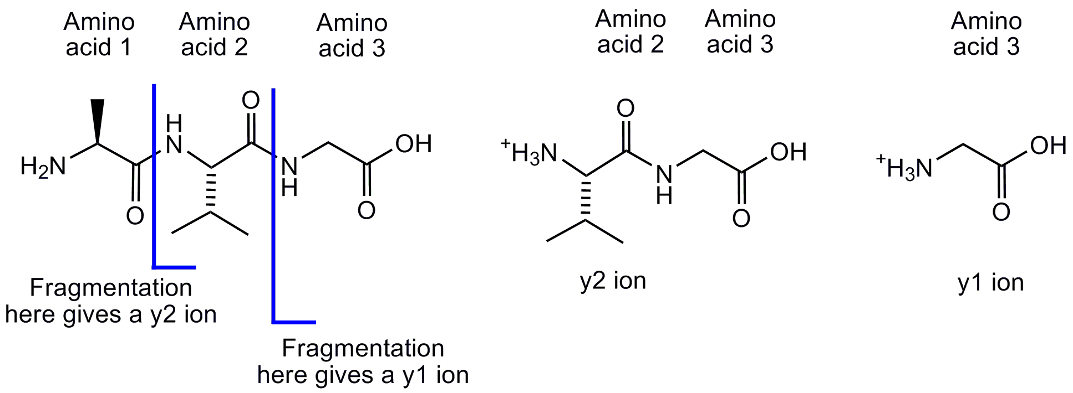
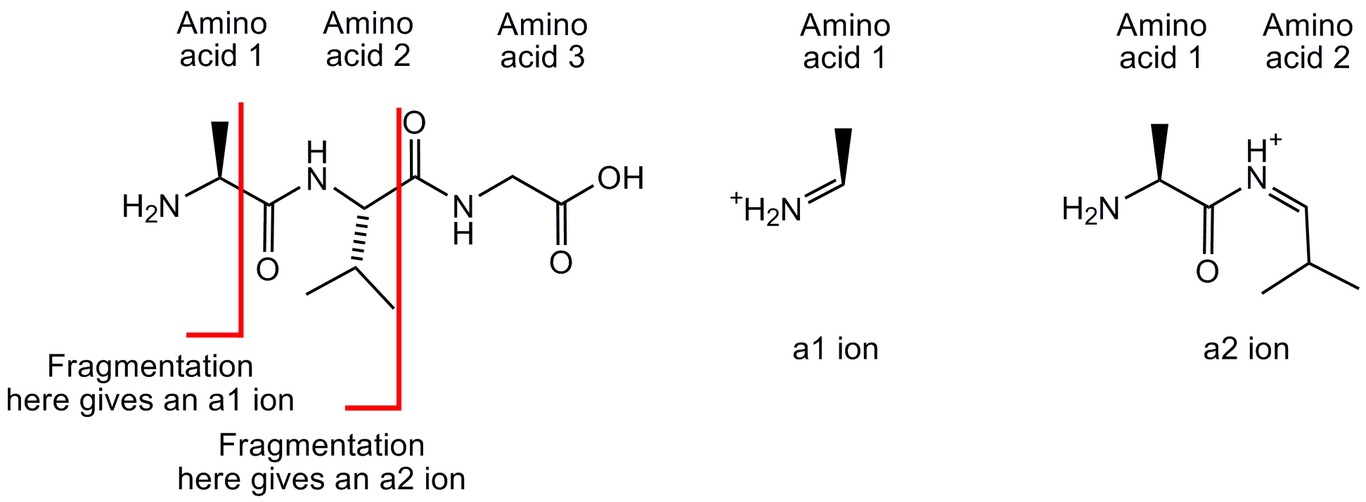
Fossilised bones potentially contain DNA and protein sequences that can be used to infer evolutionary links to modern species. Advances in mass spectrometry have made it possible to get sequence information from subpicomolar quantities of polypeptide, allowing analysis of material obtained from fossils. In reality, fossil polypeptide sequences typically have to be determined from mass-spectra using a combination of database searching and synthetic polypeptide standards. However for some younger fossils, where more material can be extracted, it is possible to determine the polypeptide sequence from the mass spectra once the ions have been identified.
The protein osteocalcin was extracted from a 42000 year old fossil bone found in Juniper Cave, Wyoming, USA.
The MS-MS spectrum of a 19 amino acid polypeptide fragment of this protein is shown below:
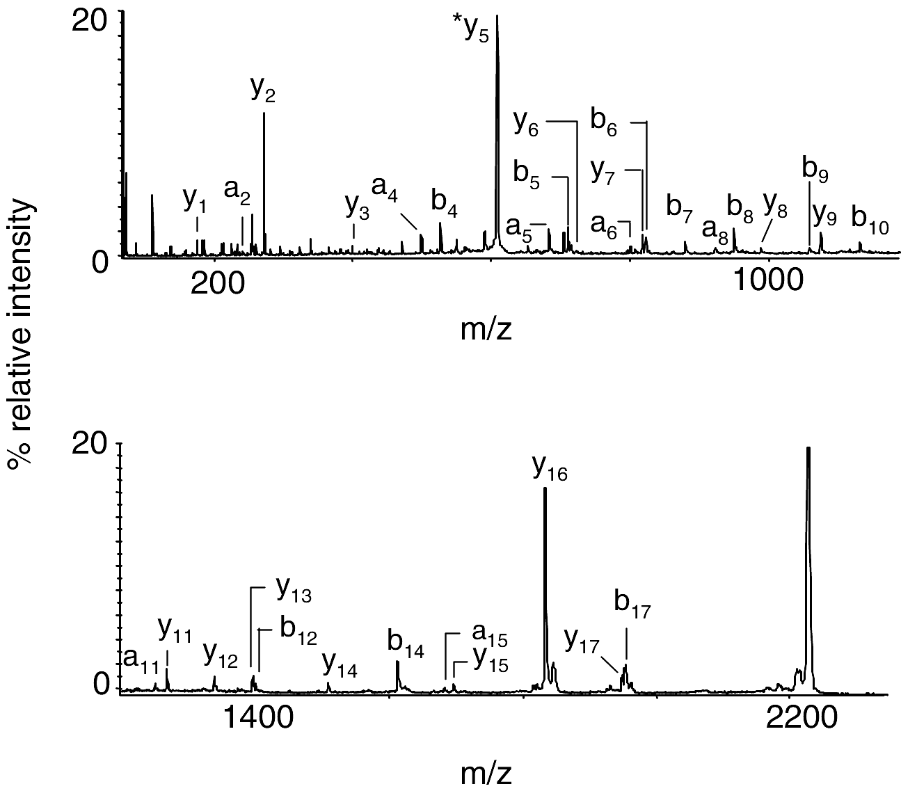

ion | m/z | ion | m/z | ion | m/z | ion | m/z
y₁ | 175.1 | b₅ | 715.3 | y₈ | 986.5 | b₁₂ | 1400.7
a₂ | 249.1 | y₆ | 726.4 | b₉ | 1069.5 | y₁₄ | 1508.8
y₂ | 272.2 | a₆ | 800.4 | y₉ | 1083.5 | b₁₄ | 1612.7
y₃ | 401.2 | y₇ | 823.4 | b₁₀ | 1140.5 | a₁₅ | 1681.8
a₄ | 501.2 | b₆ | 828.4 | a₁₁ | 1209.6 | y₁₅ | 1694.9
b₄ | 529.2 | b₇ | 885.4 | y₁₁ | 1267.6 | y₁₆ | 1831.9
y₅ | 611.4 | a₈ | 928.4 | y₁₂ | 1338.7 | y₁₇ | 1946.9
a₅ | 687.3 | b₈ | 956.5 | y₁₃ | 1395.7 | b₁₇ | 1951.9
- Using the mass spectrum and the table of ion masses determine as far possible the sequence of this polypeptide. Where there is more than one possible amino acid at a position all possibilities should be listed. The first two amino acids in the polypeptide sequence are Tyr-Leu. The polypeptide sequence also contains the amino acid hydroxyproline, Hyp, which has a mass of 131.1:
Part of the polypeptide sequence of osteocalcin from a number of different modern species are shown below:
Carp DLTVAQLESLKEVCEANLACEHMMDVSGIIAAYTAYYGPIPY
Chicken HYAQDSGVAGAPPNPLEAQREVCELSPDCDELADQIGFQEAYRRFYGPV
Cow YLDHWLGAPAPYPDPLEPKREVCELNPDCDELADHIGFQEAYRRFYGPV
Horse YLDHWLGAPAPYPDPLEPRREVCELNPDCDELADHIGFQEAYRRFYGPV
Human YLYQWLGAPVPYPDPLEPRREVCELNPDCDELADHIGFQEAYRRFYGPV
Rabbit QLINGQGAPAPYPDPLEPKREVCELNPDCDELADQVGLQDAYQRFYGPV
Sheep YLDPGLGAPAPYPDPLEPRREVCELNPDCDELADHIGFQEAYRRFYGPV
Toad SYGNNVGQGAAVGSPLESQREVCELNPDCDELADHIGFQEAYRRFYGPV

Both hydroxyproline and proline are represented by P in the polypeptide sequences shown above.
- To which modern species does the protein from the fossil appear to be most closely related?
- Creatine kinase
The factors governing energy production in muscle are important in understanding the response of the body to exercise and also in the determination of the physiological effect of cardiac and muscular diseases.
Cells use adenosine triphosphate (ATP) as the molecular energy currency; the hydrolysis of ATP to adenosine diphosphate (ADP) is often coupled with other chemical reactions.
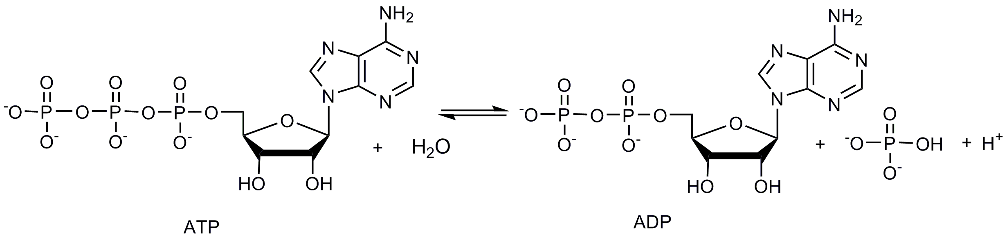
Biochemistry textbooks often represent this reaction as:
ATP + H₂O ADP + P_{i} + H⁺
In order to simplify free-energy calculations for biochemical reactions the standard free-energy change at pH 7.0, typically denoted Δ_{r}G°′, is used. The equilibrium constant at pH 7.0 is denoted K′. For the ATP hydrolysis reaction the relation between Δ_{r}G′ and the concentration of species present will therefore be:
$$Δ_{r}\text{G'}=Δ_{r}G°\text{' }+\text{RT ln}\left(\frac{[\text{ADP}][P_{i}]}{[\text{ATP}]}\right)$$
At 37 °C the value of K′ for the hydrolysis of ATP to ADP is 138000.
- A 10 mM solution of ATP is prepared in a solution buffered at pH 7.0 at 37 °C. What are the concentrations of ATP, ADP and P_{i} at equilibrium?
- What is the value of Δ_{r}G°′ at 37 °C?
One hypothesis for exhaustion after exercise is that an increase in the concentration of ADP relative to ATP could occur, leading to an increase in the value of Δ_{r}G′ for ATP hydrolysis below that required for normal cellular metabolism.
The in vivo concentration of ATP and P_{i} can be measured using ³¹P NMR. Unfortunately the concentration of ADP is too low to be measured using ³¹P NMR. Instead the concentration of ADP has to be determined indirectly from the ³¹P NMR measured concentration of phosphocreatine and the value of K’ for the enzyme creatine kinase. Creatine kinase catalyses the reaction:
creatine + ATP ADP + phosphocreatine + H⁺
To a good approximation this reaction is at equilibrium in the cell with a K′ value of 0.006. It is also known that ([creatine] + [phosphocreatine]) is maintained at 42.5×10^{–3} mol dm^{–3} in the cell.
The ³¹P NMR spectrum of a forearm muscle was measured in volunteers after a period of rest and after two different intensities of exercise (squeezing a rubber ball). These spectra were used to calculate the concentration of the following phosphorus species:
Condition | [phosphocreatine]  / mol dm^{–3} | [ATP]  / mol dm^{–3} | [P_{i}]  / mol dm^{–3}
At rest | 38.2×10^{–3} | 8.2×10^{–3} | 4.0×10^{–3}
Light exercise | 20.0×10^{–3} | 8.5×10^{–3} | 22×10^{–3}
Heavy exercise | 10.0×10^{–3} | 7.7×10^{–3} | 35×10^{–3}
Assuming that the pH of the cell remains constant at pH 7.0 during exercise:
- Calculate the concentration of ADP present under each of the three conditions.
- Calculate the value of Δ_{r}G′ for the hydrolysis of ATP under each of the three conditions.
- Comment on whether these data support the hypothesis that exhaustion after exercise arises from an increase in the value of Δ_{r}G′ for ATP hydrolysis.
Appendix
Physical constants
Name | Symbol | Value
Avogadro's constant | N_{A} | 6.0221 × 10²³ mol^{–1}
Boltzmann constant | k_{B} | 1.3807 × 10⁻²³ J K^{–1}
Gas constant | R | 8.3145 J K^{–1} mol^{–1}
Faraday constant | F | 96485 C mol^{–1}
Speed of light | c | 2.9979 × 10⁸ m s^{–1}
Planck's constant | h | 6.6261 × 10⁻³⁴ J s
Standard pressure | p° | 10⁵ Pa
Atmospheric pressure | p_{atm} | 1.01325 × 10⁵ Pa
Zero of the Celsius scale |  | 273.15 K
Amino acids
Name | Mass | Structure | Name | Mass | Structure
Alanine  Ala  A | 89.0 | 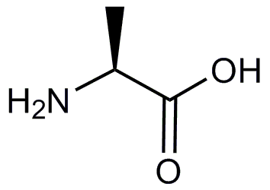 | Leucine  Leu  L | 131.1 | 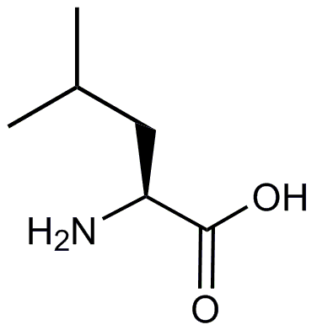
Arginine  Arg  R | 174.1 | 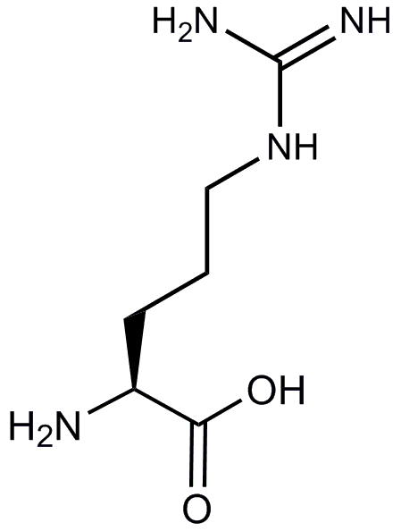 | Lysine  Lys  K | 146.1 | 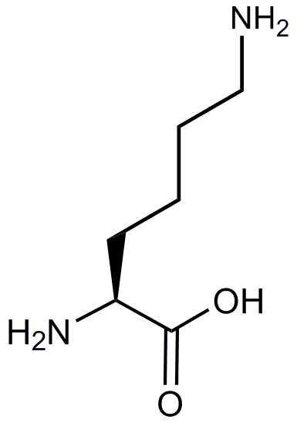
Aspartic Acid  Asp  D | 133.0 | 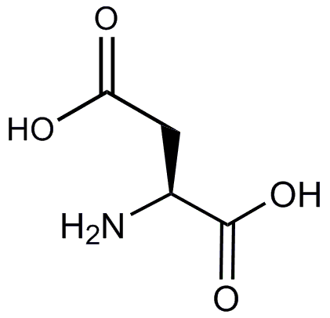 | Methionine  Met  M | 149.1 | 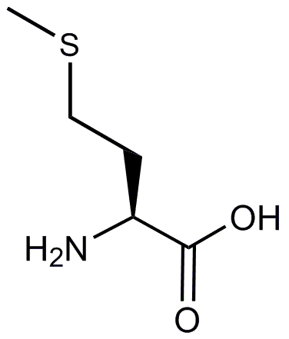
Asparagine  Asn  N | 132.1 | 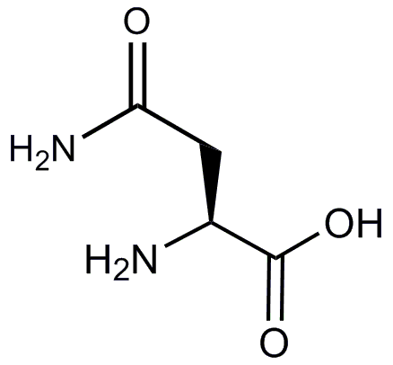 | Phenyalanine  Phe  F | 165.1 | 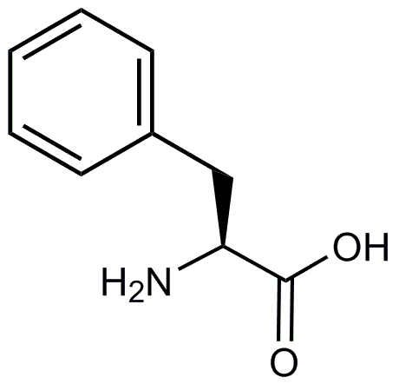
Cysteine  Cys  C | 121.0 | 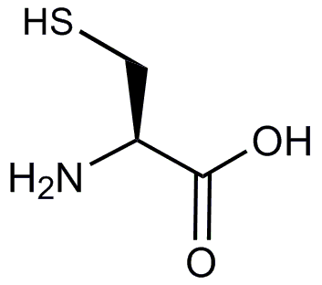 | Proline  Pro  P | 115.1 | 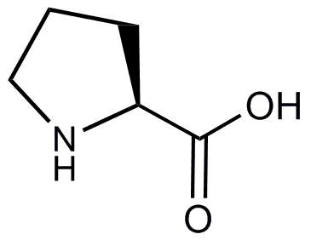
Glutamic Acid  Glu  E | 147.1 | 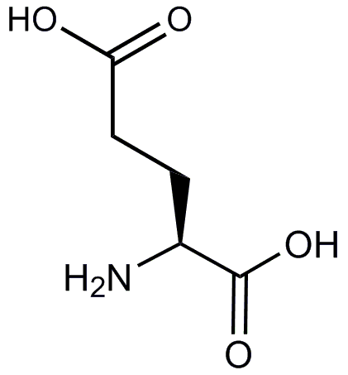 | Serine  Ser  S | 105.0 | 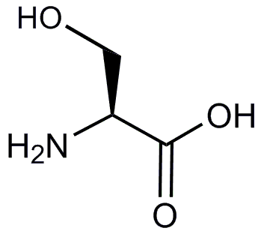
Glutamine  Gln  Q | 146.1 | 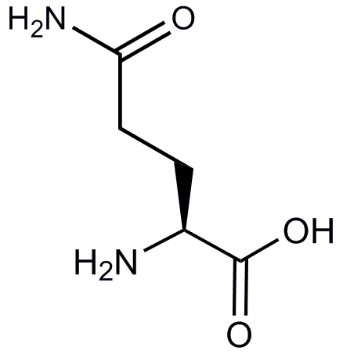 | Theronine  Thr  T | 119.1 | 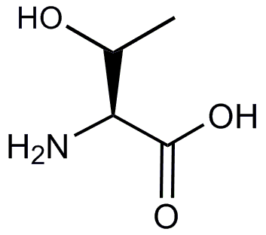
Glycine  Gly  G | 75.0 | 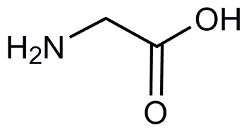 | Tryptophan  Trp  W | 204.1 | 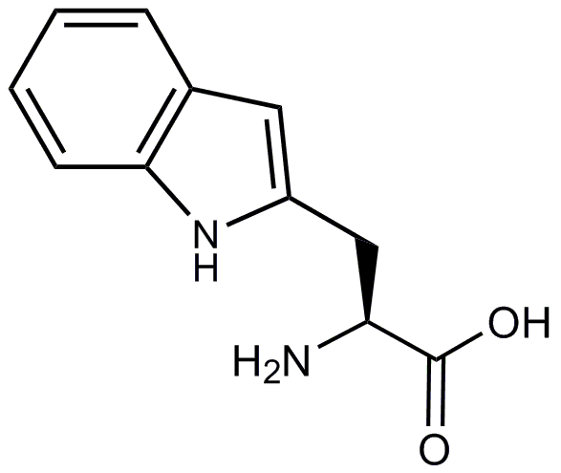
Histidine  His  H | 155.1 | 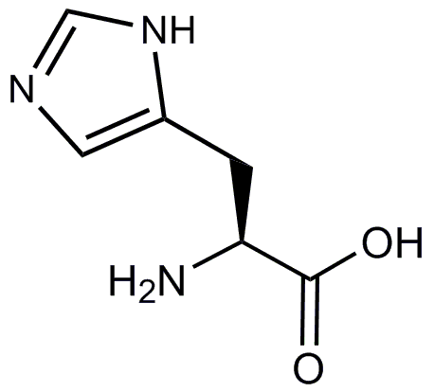 | Tyrosine  Tyr  Y | 181.1 | 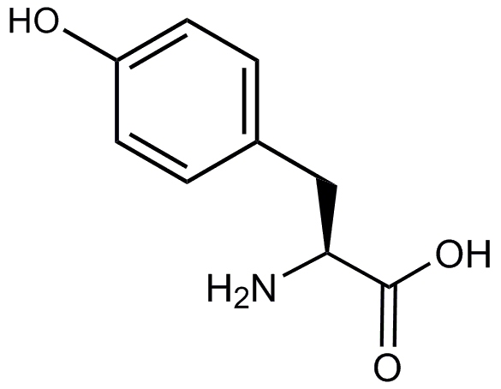
Isoleucine  Ile  I | 131.1 | 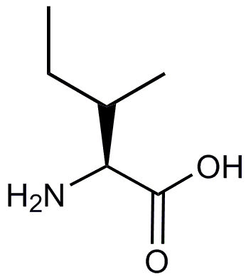 | Valine  Val  V | 117.1 | 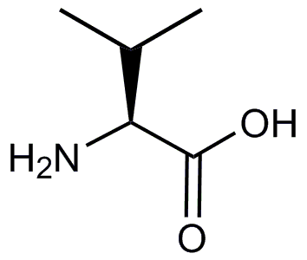
Masses given are all monoisotopic.

